**Essential Question: Should the United States have aided the Allies against the Axis powers in Europe?**

Before introducing this history lab to students, they must know who the Allied and Axis powers were during WWII. In order to analyze source 1, students should be familiar with the terms Nazi, Hitler, fascism, and Stalin. They should also be familiar with some of the events of the war, including the Battle of Britain during which London was bombed, as shown in source 2. In order to analyze source 3, students must recognize the swastika as a symbol of the Nazi Party and Germany during WWII. In order to analyze the map in source 4, students do not need extensive background knowledge but should have basic map skills, and will need to understand the terms “German Reich,” “occupied territories,” “German allies,” “dependent states,” and “neutral.”

Related content they should know:

* Allied Powers in WWII
* Axis Powers in WWII
* Nazis
* Hitler
* Fascism
* Stalin

Name _____________________________________________ Period _____ Date _____________________

SS.912.A.6.1 Examine causes, course, and consequences of World War II on the United States and the world.

**Essential Question: Should the United States have aided the Allies against the Axis powers in Europe?**

|  |  |  |
| --- | --- | --- |
| Source | Main Idea / Message / Important Details | How does this document answer the essential question? |
| Source 1  “Ho hum!” Political cartoon by Dr. Seuss, 1941 |  |  |
| Source 2  Photograph of bombing of London, 1940 |  |  |
| Source 3  “We’re Fighting to Prevent This” propaganda poster, 1943. |  |  |
| Source 4  Map of Europe, 1942 |  |  |

Thesis: __________________________________________________________________________________________________________________________________________________________________________________________________________________________________________________________________________________________________________________________________________________________________

Source 1 – Political Cartoon by Dr. Seuss, 1941

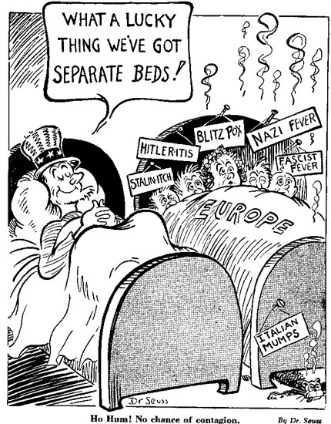

Source 2 – Photo of the aftermath of Germany’s bombing of London, 1940

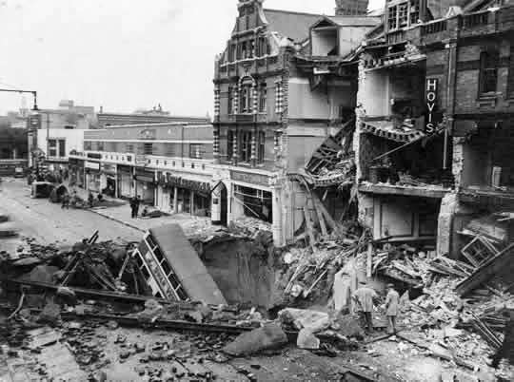

Source 3 – American propaganda poster created in 1943

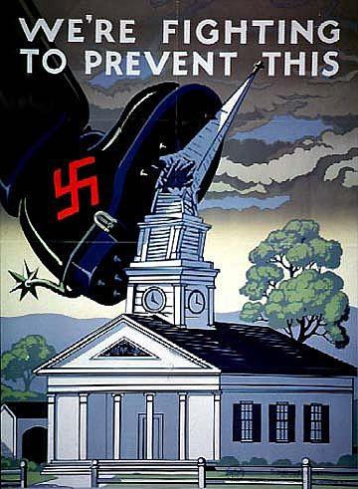

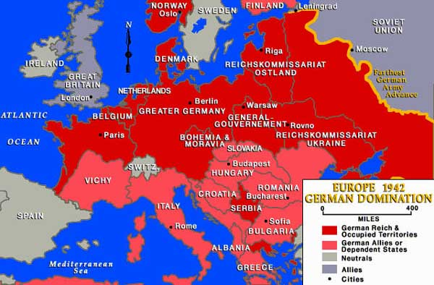Source 4 – Map of Europe showing German expansion as of 1942