**Building Blocks for History Lab:**

SS.912.A.4.5 Examine causes, course, and consequences of United States involvement in World War I.

**Essential Question: Was the Treaty of Versailles a fair and effective settlement for lasting world peace?**

Before introducing this history lab to students, they must know that the Treaty of Versailles was the peace settlement that ended World War I. Students should know the term “reparations,” which were included in the treaty as a punishment for Germany and to make them pay for the war. Additionally, students need to be familiar with the League of Nations and know that it was established during the Paris Peace Conference as an international organization to promote peace in the world, but that the United States did not join. Finally, students need to know that it was President Woodrow Wilson who represented the United States at the Paris Peace Conference, and whose idea it was to create a League of Nations in the first place. Students will need fairly well developed text analysis skills to be able to complete this history lab.

Related content they should know:

* Treaty of Versailles
* Reparations
* League of Nations



Name _____________________________________________ Period _____ Date _____________________

SS.912.A.4.5 Examine causes, course, and consequences of United States involvement in World WarI.

**Essential Question: Was the Treaty of Versailles a fair and effective settlement for lasting world peace?**

|  |  |  |
| --- | --- | --- |
| Source | Main Idea / Message / Important Details | How does this document answer the essential question? |
| Source 1  Excerpt from Treaty of Versailles |  |  |
| Source 2  Political cartoon from *New York World* newspaper |  |  |
| Source 3  Political cartoon on the League of Nations |  |  |
| Source 4  Excerpt from Woodrow Wilson press release, 1921 |  |  |

Thesis: _________________________________________________________________________________________________________________________________________________________________________________________________________________________________________________________________________________________________________________________________________________________________________________________________________

Source 1 – Excerpt from Treaty of Versailles on the subject of reparations

### Article 231

The Allied and Associated Governments affirm and Germany accepts the responsibility of Germany and her allies for causing all the loss and damage to which the Allied and Associated Governments and their nationals have been subjected as a consequence of the war imposed upon them by the aggression of Germany and her allies.

**Article 232**

The Allied and Associated Governments recognise that the resources of Germany are not adequate, after taking into account permanent diminutions of such resources which will result from other provisions of the present Treaty, to make complete reparation for all such loss and damage.

The Allied and Associated Governments, however, require, and Germany undertakes, that she will make compensation for all damage done to the civilian population of the Allied and Associated Powers and to their property during the period of the belligerency of each as an Allied or Associated Power against Germany by such aggression by land, by sea and from the air, and in general all damage as defined in Annex l hereto.

In accordance with Germany's pledges, already given, as to complete restoration for Belgium, Germany undertakes, in addition to the compensation for damage elsewhere in this Part provided for, as a consequence of the violation of the Treaty of 1839, to make reimbursement of all sums which Belgium has borrowed from the Allied and Associated Governments up to November 11, 1918, together with interest at the rate of five per cent (5%) per annum on such sums. This amount shall be determined by the Reparation Commission, and the German Government undertakes thereupon forthwith to make a special issue of bearer bonds to an equivalent amount payable in marks gold, on May 1, 1926, or, at the option of the German Government, on the 1st of May in any year up to 1926. Subject to the foregoing, the form of such bonds shall be determined by the Reparation Commission. Such bonds shall be handed over to the Reparation Commission, which has authority to take and acknowledge receipt thereof on behalf of Belgium.

Source 2 – Political Cartoon on the subject of reparations from *New York World*

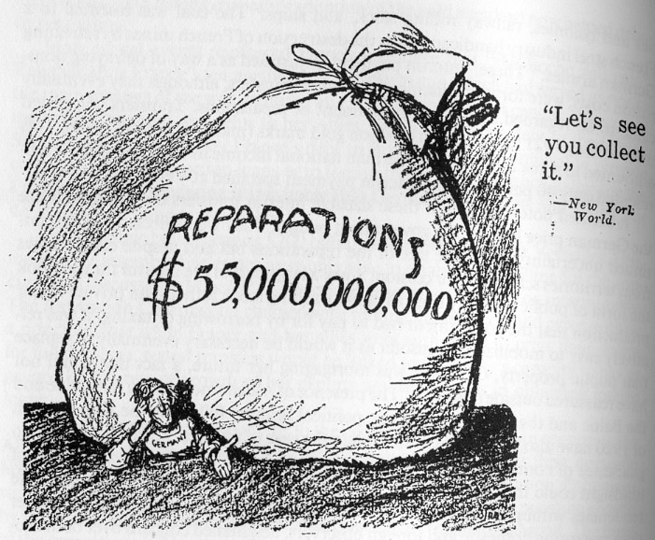

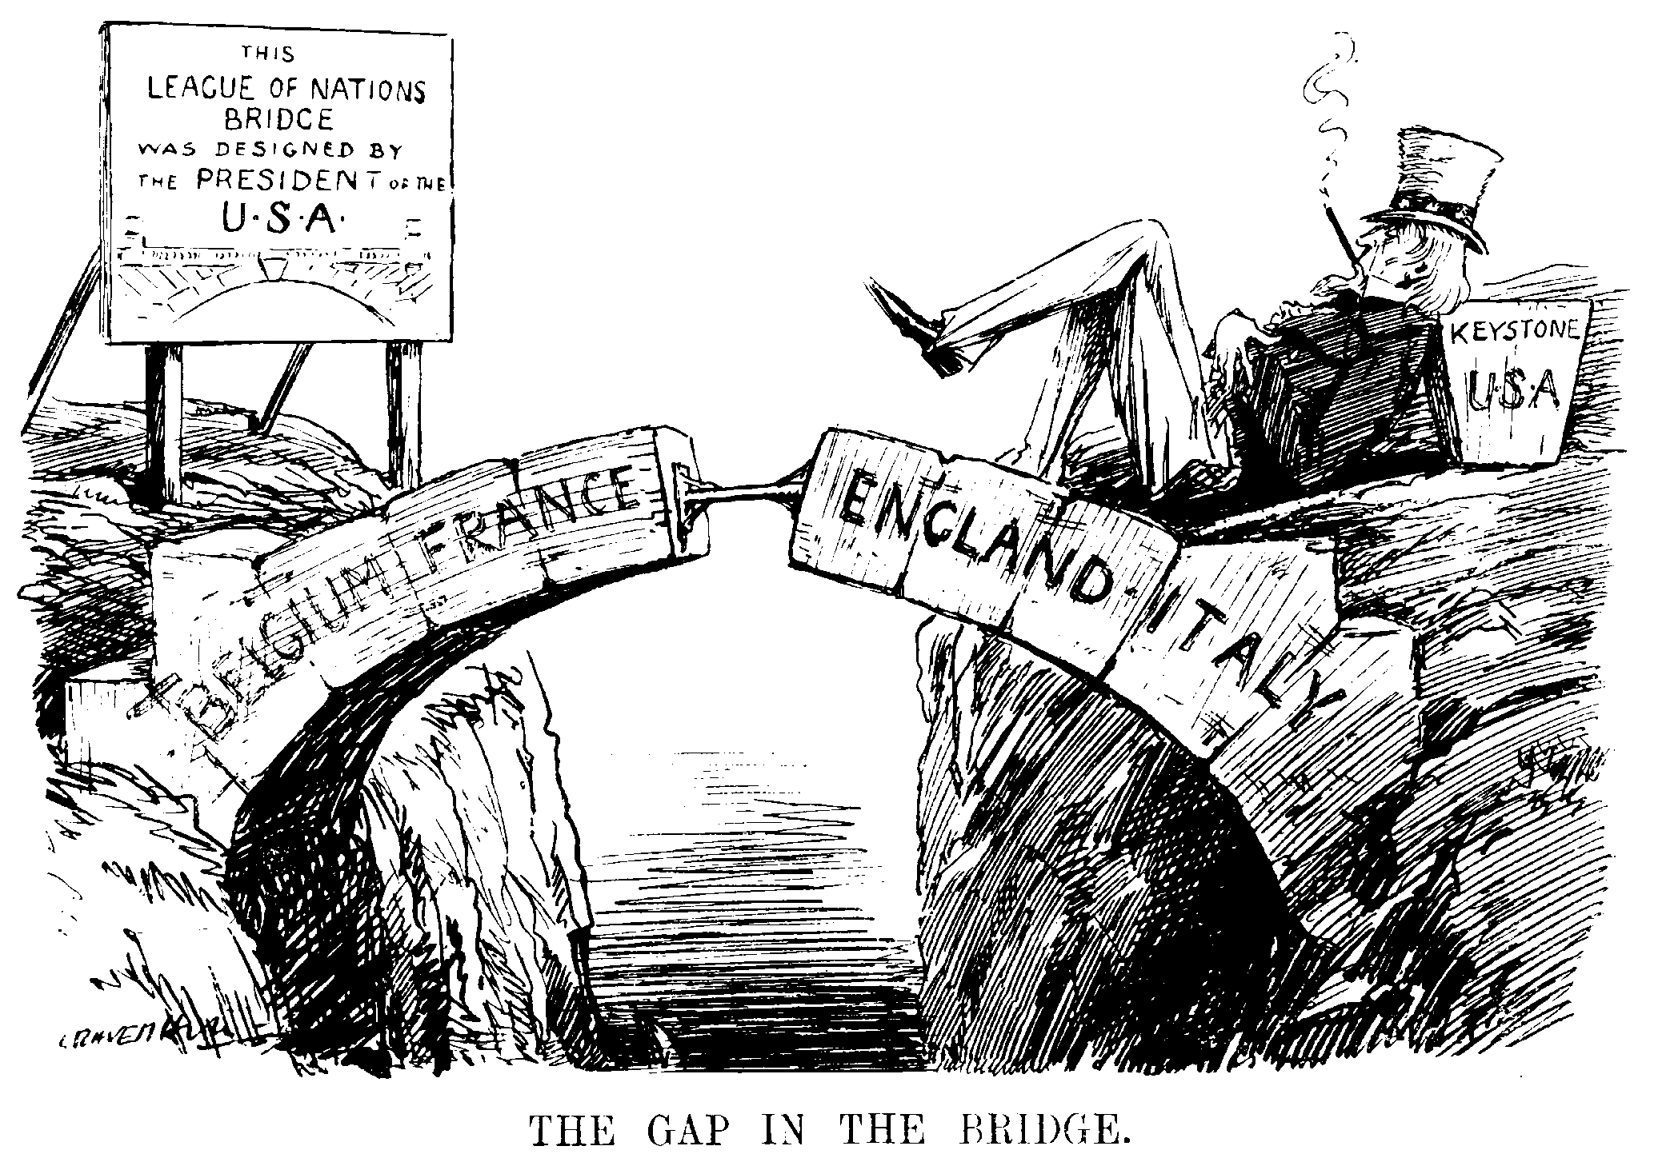Source 3 – Political cartoon on the subject of the League of Nations

Source 4 – Excerpt from a press statement on behalf of Woodrow Wilson

**BACKGROUND**

*This press statement, released as Wilson left office in 1921 by William Gibbs McAdoo—who was both Wilson’s son-in-law and his treasury secretary—defends the President’s handling of the Treaty of Versailles. McAdoo argued that Wilson had “laid the foundations of world peace and a new order” and made a “matchless contribution to his time” in the treaty. “Whatever may be the imperfections of the Treaty from a political or economic standpoint,” McAdoo wrote, “Woodrow Wilson did not fail.”*

EXCERPT

“I do not agree with those who hastily and inconsiderately adjudge the President’s work at the Peace Conference a failure. Whatever may be the imperfections of the Treaty from a political or economic standpoint, Woodrow Wilson did not fail. The outstanding thing for which he fought, the thing that transcends political and economic considerations, is the permanent peace of the world. Unless this is secured all else is failure; without this the sublimest hope of humanity is sunk in the black abyss; without this all political and economic adjustments are unstable and sooner or later will disappear.”