**Building Blocks for History Lab:**

SS.912.A.6.13 – Analyze significant foreign policy events during the Truman, Eisenhower, Kennedy, Johnson, and Nixon administrations.

**Essential Question: Did American presidents have good reasons to fight a war in Vietnam?**

Before introducing this history lab to students, they must be familiar with the causes, course, and consequences of the Vietnam War. In order to accurately analyze source 1, students must know the term Vietcong, and understand that the Vietcong was considered an enemy of the United States, as they fought on behalf of spreading Communism throughout Vietnam. Students should also be able to identify Laos, Cambodia, Thailand, etc. as countries neighboring Vietnam that the United States feared would fall to Communism if it was not first stopped in Vietnam. In order to comprehend the excerpt in source 3, students should be introduced to the terms “peasant” and Saigon. Finally, to accurately analyze the political cartoon in source 4, students must recognize the figure of Richard Nixon, and know that he was elected president in 1968 and then ran for president again in 1972 on the promise to end the war in Vietnam.

Related content they should know:

* Vietcong
* Domino theory
* Richard Nixon
* 1968 & 1972 presidential elections

Name _____________________________________________ Period _____ Date _____________________

SS.912.A.6.13 – Analyze significant foreign policy events during the Truman, Eisenhower, Kennedy, Johnson, and Nixon administrations.

**Essential Question: Did American presidents have good reasons to fight a war in Vietnam?**

|  |  |  |
| --- | --- | --- |
| Source | Main Idea / Message / Important Details | How does this document answer the essential question? |
| Source 1  Photograph of victims of Vietcong raids |  |  |
| Source 2  Image illustrating domino theory |  |  |
| Source 3  Speech excerpt from “A Time to Break Silence” by Martin Luther King, Jr., 1967 |  |  |
| Source 4  Political cartoon, 1972 |  |  |

Thesis: _________________________________________________________________________________________________________________________________________________________________________________________________________________________________________________________________________________________________________________________________________________________________________________________________________

Source 1 – Photographic image showing a Vietnamese family standing around the casket of their deceased relative who died as a result of Vietcong raids in the early 1960s.

[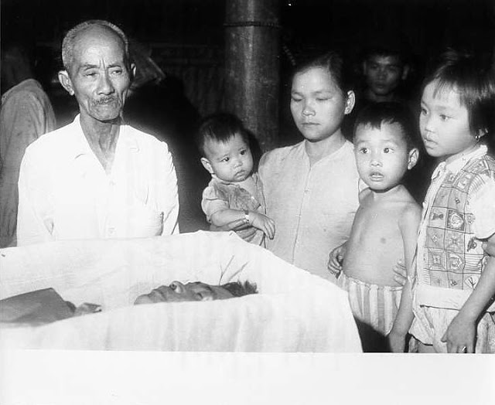](http://1.bp.blogspot.com/-rlNZ73myBCw/UUVuUJLDRJI/AAAAAAAACAE/TVlb2GTSE3c/s1600/vietcong-brutal-006.jpg)

Source 2 – Image illustrating the domino theory

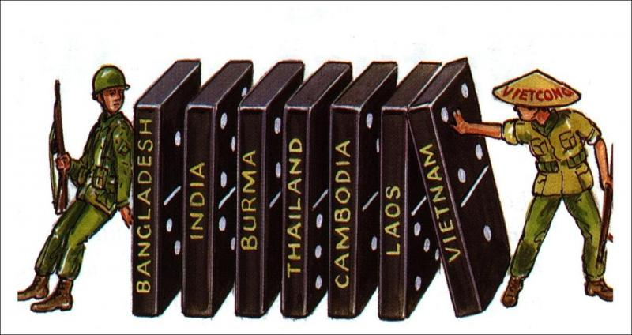

Source 3 – Excerpt from Martin Luther King Jr.’s 1967 speech about the Vietnam War.

*"Now they languish under our bombs and consider us, not their fellow Vietnamese, the real enemy. They move sadly and apathetically as we herd them off the land of their fathers into concentration camps where minimal social needs are rarely met. They know they must move on or be destroyed by our bombs.*

*"So they go, primarily women and children and the aged. They watch as we poison their water, as we kill a million acres of their crops. They must weep as the bulldozers roar through their areas preparing to destroy the precious trees. They wander into the hospitals with at least twenty casualties from American firepower for one Vietcong-inflicted injury. So far we may have killed a million of them, mostly children. They wander into the towns and see thousands of the children, homeless, without clothes, running in packs on the streets like animals. They see the children degraded by our soldiers as they beg for food. They see the children selling their sisters to our soldiers, soliciting for their mothers.*

*"What do the peasants think as we ally ourselves with the landlords and as we refuse to put any action into our many words concerning land reform? What do they think as we test out our latest weapons on them, just as the Germans tested out new medicine and new tortures in the concentration camps of Europe? Where are the roots of the independent Vietnam we claim to be building? Is it among these voiceless ones?*

*"We have destroyed their two most cherished institutions: the family and the village. We have destroyed their land and their crops. We have cooperated in the crushing of the nation's only noncommunist revolutionary political force, the unified Buddhist Church. We have supported the enemies of the peasants of Saigon. We have corrupted their women and children and killed their men.*

*"Now there is little left to build on, save bitterness. Soon the only solid physical foundations remaining will be found at our military bases and in the concrete of the concentration camps we call 'fortified hamlets.' The peasants may well wonder if we plan to build our new Vietnam on such grounds as these. Could we blame them for such thoughts? We must speak for them and raise the questions they cannot raise. These, too, are our brothers."*

Source 4 – Political cartoon by Herbert Herblock, 1972

