**Building Blocks for History Lab:**

SS.912.A.7.11 Analyze the foreign policy of the United States as it relates to Africa, Asia, the Caribbean, Latin America, and the Middle East.

**Essential Question: How successful has US foreign policy in the Middle East been?**

Before introducing this history lab to students, they must be familiar with several events and issues related to U.S.-Middle East foreign policy during the late 20th-early 21st century. In order to understand Source 1, students must be familiar with the oil crisis that resulted from OPEC’s oil embargo as a response to U.S. support of Israel during the Yom Kippur War between Israel and a coalition of Arab states led by Egypt. Students must also know about the Camp David Accords, in which a peace treaty was finally signed between Egypt and Israel, facilitated by President Jimmy Carter. The Source 2 photograph shows the leaders of Egypt, Israel, and the United States standing together during those meetings at Camp David, where the peace treaty was negotiated and signed. Additionally, students must know that the Ayatollah Khomeini came to power during the Iranian Revolution, and soon after there was a diplomatic crisis between the United States and Iran when a group of Iranian students took over the U.S. embassy in Tehran and held 52 Americans hostage for over a year. Finally, students should recognize that 9/11 was a terrorist attack that led to the destruction of the Twin Towers in New York City, and ultimately led to increased U.S. military involvement in the Middle East and the War on Terror.

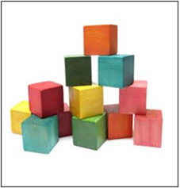Related content they should know:

* OPEC
* Oil crisis
* Camp David Accords
* Iran hostage crisis
* 9/11
* War on Terror

Name _____________________________________________ Period _____ Date _____________________

SS.912.A.7.11 Analyze the foreign policy of the United States as it relates to Africa, Asia, the Caribbean, Latin America, and the Middle East.

**Essential Question: How successful has US foreign policy in the Middle East been?**

|  |  |  |
| --- | --- | --- |
| Source | Main Idea / Message / Important Details | How does this document answer the essential question? |
| Source 1  Images of 1970s gas shortage |  |  |
| Source 2  Photograph of Camp David Accords |  |  |
| Source 3  Iran Hostage Crisis Time Magazine cover |  |  |
| Source 4  9/11 Political Cartoon |  |  |

Thesis: _________________________________________________________________________________________________________________________________________________________________________________________________________________________________________________________________________________________________________________________________________________________________________________________________________

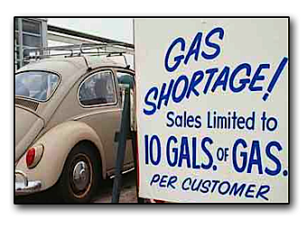Source 1 – Images reflecting the 1970s gas shortage

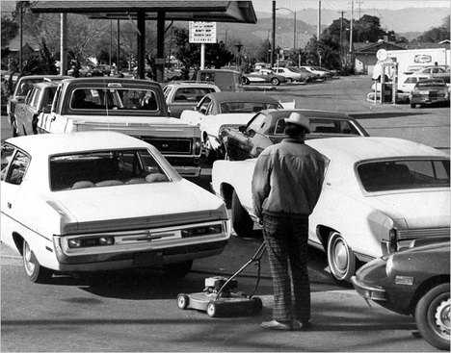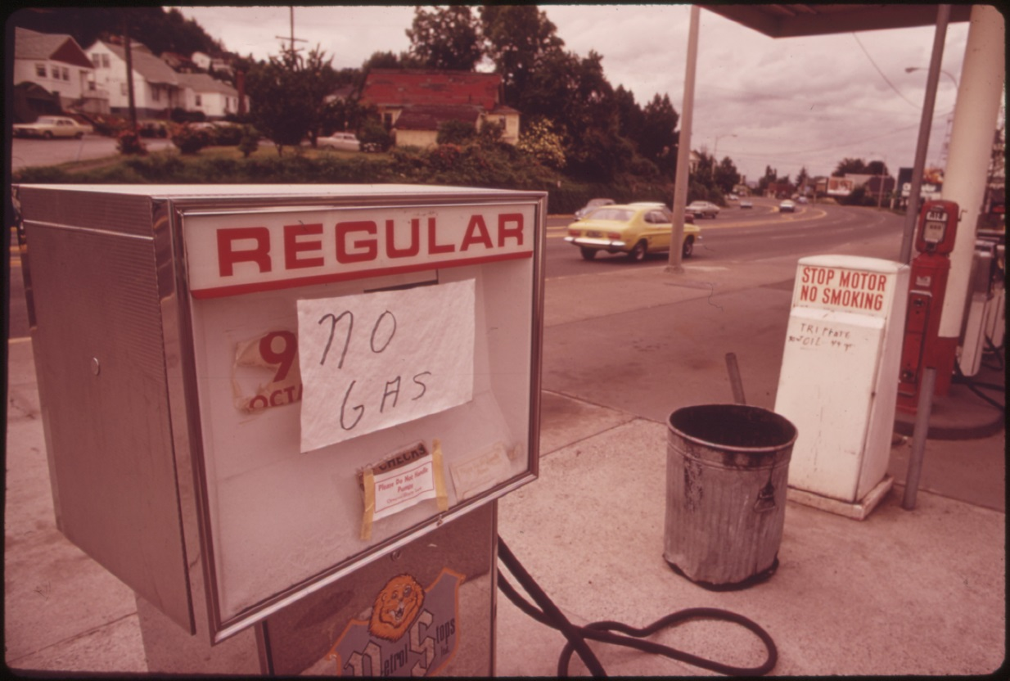

Source 2 – Photograph of Camp David Accords, 1978

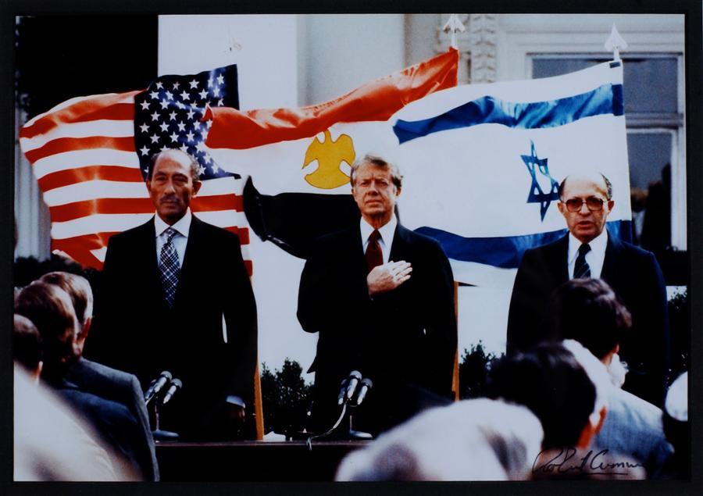

Source 3 – Time Magazine cover featuring Ayatollah Khomeini and Jimmy Carter during the Iran Hostage Crisis

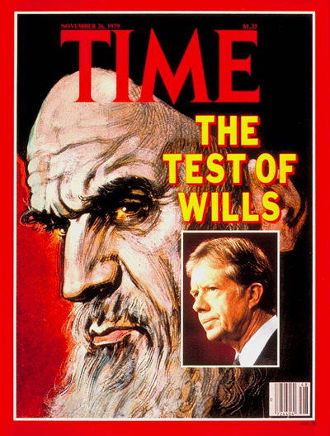

Source 4 – 9/11 Political cartoon

