**Building Blocks for History Lab:**

SS.912.A.7.8 Analyze significant Supreme Court decisions relating to integration, busing, affirmative action, the rights of the accused, and reproductive rights.

**Essential Question: What role has the US Supreme Court played in expanding individual rights since the 1960s?**

Before introducing this history lab to students, they should be familiar with some of the landmark Supreme Court decisions, but do not necessarily need to know a lot about these decisions, as sources 1, 2, and 3 all provide students with what they need to know in order to answer the essential question. Because there is not a lot of required background knowledge, this history lab could be used as an introductory activity when teaching students SS.912.A.7.8. In order to successfully analyze source 4, students should understand the term “affirmative action” and its implications. Students may need to be told that this cartoon relates to the *Regents of the University of California v. Bakke* Supreme Court case, which upheld affirmative action, allowing race to be one of several factors in college admission policy. Alternatively, teachers may want to prompt students to do some research to find out which Supreme Court case relates to source 4.

Related content they should know:

* Supreme Court
* Affirmative action

Name _____________________________________________ Period _____ Date _____________________

SS.912.A.7.8 Analyze significant Supreme Court decisions relating to integration, busing, affirmative action, the rights of the accused, and reproductive rights.

**Essential Question: What role has the US Supreme Court played in expanding individual rights since the 1960s?**

|  |  |  |
| --- | --- | --- |
| Source | Main Idea / Message / Important Details | How does this document answer the essential question? |
| Source 1  Newspaper front page, 1954 |  |  |
| Source 2  Comic illustrating *Gideon v. Wainwright*, 1963 |  |  |
| Source 3  Excerpt from SC opinion in *Roe v. Wade* |  |  |
| Source 4  Political cartoon addressing the issue of affirmative action |  |  |

Thesis: _________________________________________________________________________________________________________________________________________________________________________________________________________________________________________________________________________________________________________________________________________________________________________________________________________

Source 1 – Newspaper front page headlines, 1954

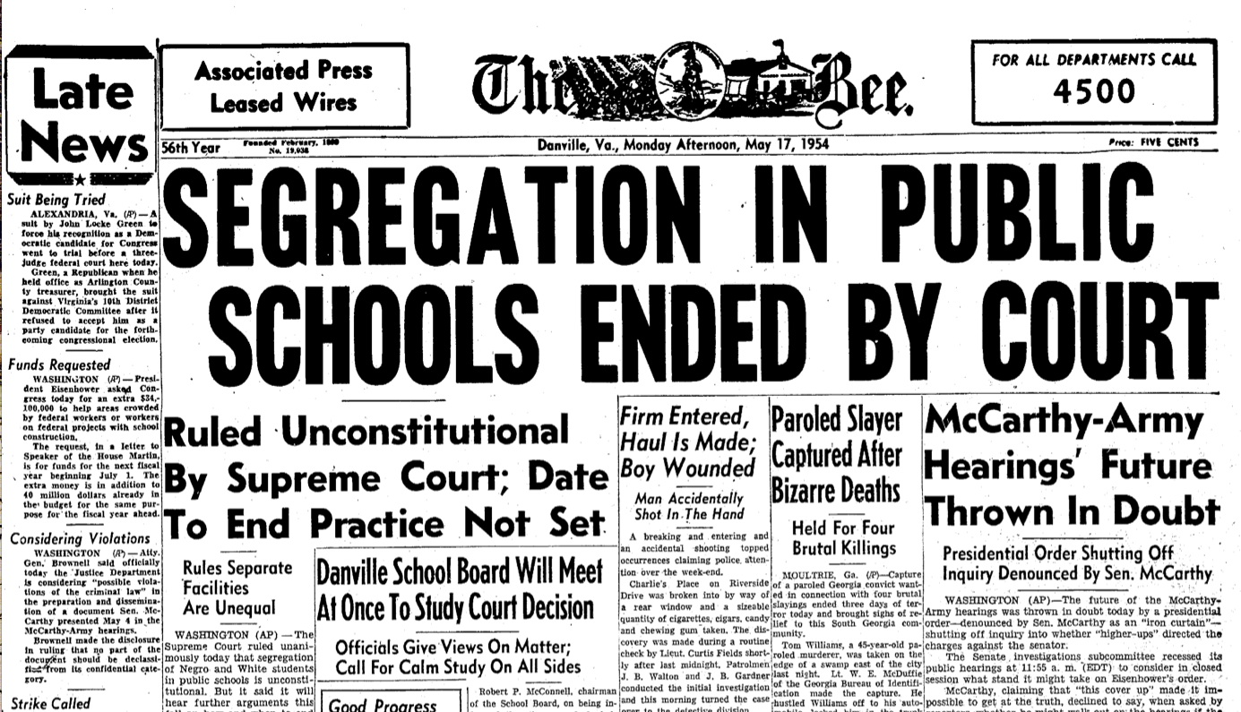

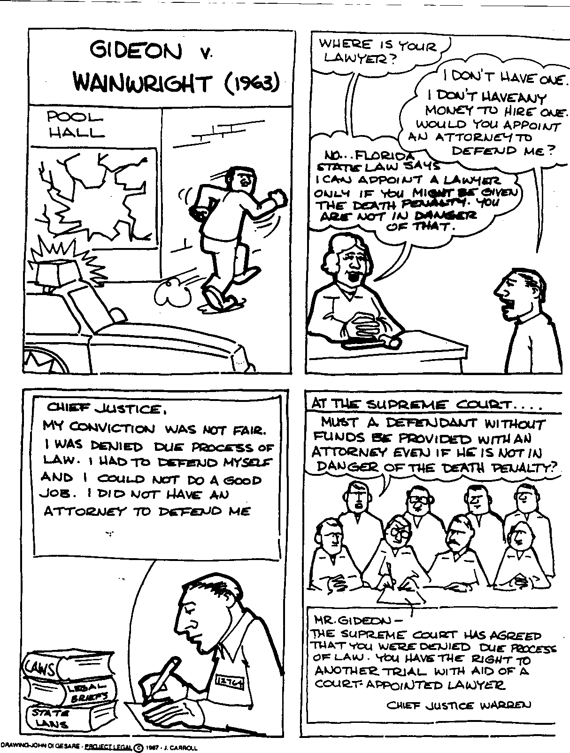Source 2 – Comic illustrating Supreme Court decision in *Gideon v. Wainwright*, 1963

Source 3 – Excerpt from Supreme Court majority opinion in *Roe v. Wade* case

MR. JUSTICE BLACKMUN delivered the opinion of the Court. Chief Justice Burger and Justices Douglas, Brennan, Stewart, Marshall and Powell joined the opinion.

…We forthwith acknowledge our awareness of the sensitive and emotional nature of the abortion controversy, of the vigorous opposing views, even among physicians, and of the deep and seemingly absolute convictions that the subject inspires. One's philosophy, one's experiences, one's exposure to the raw edges of human existence, one's religious training, one's attitudes toward life and family and their values, and the moral standards one establishes and seeks to observe, are all likely to influence and to color one's thinking and conclusions about abortion.

…The principal thrust of appellant's attack on the Texas statutes is that they improperly invade a right, said to be possessed by the pregnant woman, to choose to terminate her pregnancy. Appellant would discover this right in the concept of personal "liberty" embodied in the Fourteenth Amendment's Due Process Clause; or in personal, marital, familial, and sexual privacy said to be protected by the Bill of Rights or its penumbras.

…The Constitution does not explicitly mention any right of privacy. …[T]he Court has recognized that a right of personal privacy, or a guarantee of certain areas or zones of privacy, does exist under the Constitution. … This right of privacy, whether it be founded in the Fourteenth Amendment's concept of personal liberty and restrictions upon state action, as we feel it is, or, as the District Court determined, in the Ninth Amendment's reservation of rights to the people, is broad enough to encompass a woman's decision whether or not to terminate her pregnancy. The detriment that the State would impose upon the pregnant woman by denying this choice altogether is apparent. Specific and direct harm medically diagnosable even in early pregnancy may be involved. Maternity, or additional offspring, may force upon the woman a distressful life and future. Psychological harm may be imminent. Mental and physical health may be taxed by child care. There is also the distress, for all concerned, associated with the unwanted child, and there is the problem of bringing a child into a family already unable, psychologically and otherwise, to care for it. In other cases, as in this one, the additional difficulties and continuing stigma of unwed motherhood may be involved. All these are factors the woman and her responsible physician necessarily will consider in consultation.

On the basis of elements such as these, appellant and some amici argue that the woman's right is absolute and that she is entitled to terminate her pregnancy at whatever time, in whatever way, and for whatever reason she alone chooses. With this we do not agree. Appellant's arguments that Texas either has no valid interest at all in regulating the abortion decision, or no interest strong enough to support any limitation upon the woman's sole determination, are unpersuasive. The Court's decisions recognizing a right of privacy also acknowledge that some state regulation in areas protected by that right is appropriate. As noted above, a State may properly assert important interests in safeguarding health, in maintaining medical standards, and in protecting potential life. At some point in pregnancy, these respective interests become sufficiently compelling to sustain regulation of the factors that govern the abortion decision. The privacy right involved, therefore, cannot be said to be absolute….We, therefore, conclude that the right of personal privacy includes the abortion decision, but that this right is not unqualified, and must be considered against important state interests in regulation.

… (a) For the stage prior to approximately the end of the first trimester, the abortion decision and its effectuation must be left to the medical judgment of the pregnant woman's attending physician.

(b) For the stage subsequent to approximately the end of the first trimester, the State, in promoting its interest in the health of the mother, may, if it chooses, regulate the abortion procedure in ways that are reasonably related to maternal health.

(c) For the stage subsequent to viability, the State in promoting its interest in the potentiality of human life may, if it chooses, regulate, and even proscribe, abortion except where it is necessary, in appropriate medical judgment, for the preservation of the life or health of the mother.

This holding, we feel, is consistent with the relative weights of the respective interests involved, with the lessons and examples of medical and legal history, with the lenity of the common law, and with the demands of the profound problems of the present day. The decision leaves the State free to place increasing restrictions on abortion as the period of pregnancy lengthens, so long as those restrictions are tailored to the recognized state interests. The decision vindicates the right of the physician to administer medical treatment according to his professional judgment up to the points where important state interests provide compelling justifications for intervention. Up to those points, the abortion decision in all its aspects is inherently, and primarily, a medical decision, and basic responsibility for it must rest with the physician. If an individual practitioner abuses the privilege of exercising proper medical judgment, the usual remedies, judicial and intra-professional, are available.

Source 4 – Political Cartoon addressing the issue of affirmative action.

