**Building Blocks for History Lab:**

SS.912.A.2.1 Review causes and consequences of the Civil War.

**Essential Question: How effectively did the Reconstruction governments rule the South?**

Before introducing this history lab to students, they must be familiar with the terms that were established as part of the Reconstruction Acts passed by the Radical Republicans in Congress after the Civil War. As part of the Reconstruction Acts, the South was divided into five military districts. Additionally, each former Confederate state would need to draft a new constitution, ratify the Fourteenth Amendment, and grant voting rights to black men to be re-admitted to the Union. Students should be familiar with the events that occurred after the end of the Civil War during Reconstruction and also what happened after the Compromise of 1877 when Reconstruction is said to have ended, including the rise of lynching and oppressive Black Codes and Jim Crow Laws. Related content they should know:

* Black Codes
* Fifteenth Amendment
* Fourteenth Amendment
* Jim Crow laws
* Ku Klux Klan
* Radical Republicans
* Reconstruction Act

Name _____________________________________________ Period _____ Date _____________________

SS.912.A.2.1 Review causes and consequences of the Civil War.

**Essential Question: How effectively did the Reconstruction governments rule the South?**

|  |  |  |
| --- | --- | --- |
| Source | Main Idea / Message / Important Details | How does this document answer the essential question? |
| Source 1  Political Cartoon “Shall We Call Home Our Troops?” in Harper's Weekly, 1875. |  |  |
| Source 2  Map Lynching Statistics 1882-1968 |  |  |
| Source 3  15th Amendment to the U.S. Constitution |  |  |
| Source 4  Political cartoon, “Of Course He Wants to Vote the Democratic Ticket!” Harper's Weekly, 1876. |  |  |

Thesis: ________________________________________________________________________________________________________________________________________________________________________________________________________________________________________________________________________________________________________________________________________________________________________________________________________

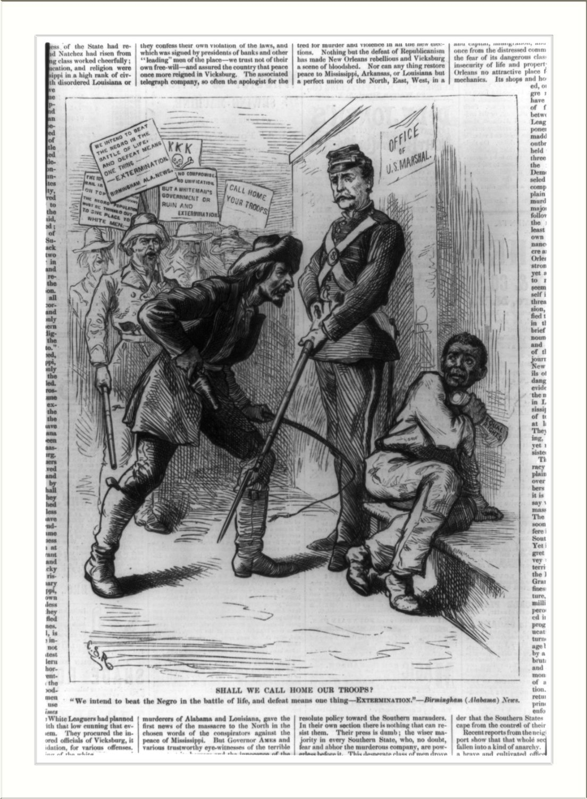Source 1 – Political Cartoon “Shall We Call Home Our Troops?”

­­­­

Source 2 – Map featuring lynching statistics

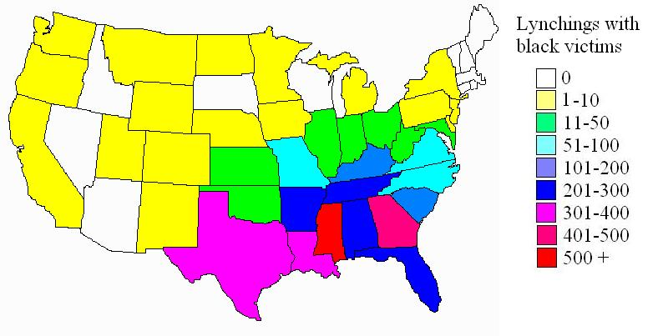

Source 3 – 15th Amendment

15th Amendment

Amendment XV

Section 1.

The right of citizens of the United States to vote shall not be denied or abridged by the United States or by any state on account of race, color, or previous condition of servitude.

Section 2.

The Congress shall have power to enforce this article by appropriate legislation.

Source 4 – Political Cartoon, “Of Course He Wants to Vote the Democratic Ticket!”

