**Building Blocks for History Lab:**

SS.912.A.7.12 Analyze political, economic, and social concerns that emerged at the end of the 20th and into the 21st century.

**Essential Question: Should stricter laws regulating firearms be enacted?**

Students do not need much background knowledge prior to completing this history lab. However, they should know that the 2nd Amendment is an amendment to the U.S. Constitution guaranteeing the right to bear arms. Students must have skills required to analyze political cartoons, understand infographics, and comprehend written excerpts in order to successfully complete this history lab.

Related content they should know:

* 2nd Amendment

Name _____________________________________________ Period _____ Date _____________________

SS.912.A.7.12 Analyze political, economic, and social concerns that emerged at the end of the 20th and into the 21st century.

**Essential Question: Should stricter laws regulating firearms be enacted?**

|  |  |  |
| --- | --- | --- |
| Source | Main Idea / Message / Important Details | How does this document answer the essential question? |
| Source 1  2nd Amendment to the U.S. Constitution |  |  |
| Source 2  Gun control political cartoon |  |  |
| Source 3  Infographic relating to guns in America |  |  |
| Source 4  Excerpt from news article, 2015 |  |  |

Thesis: _________________________________________________________________________________________________________________________________________________________________________________________________________________________________________________________________________________________________________________________________________________________________________________________________________

Source 1 – 2nd Amendment

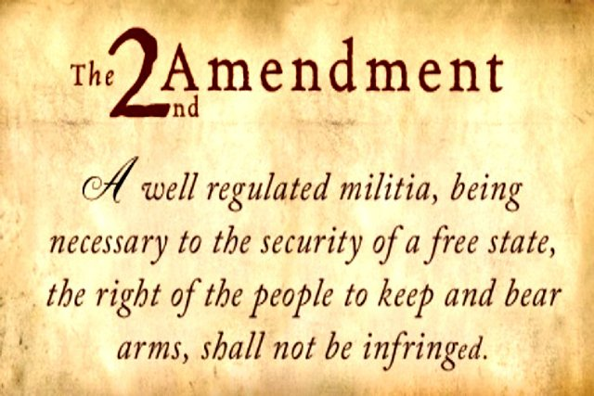

Source 2 – Political cartoon relating to gun control, 2013

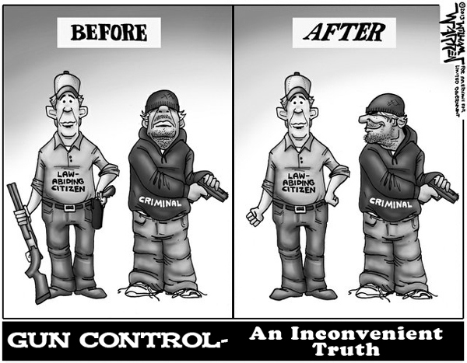

Source 3 – Infographic relating to guns in America, featuring various statistics

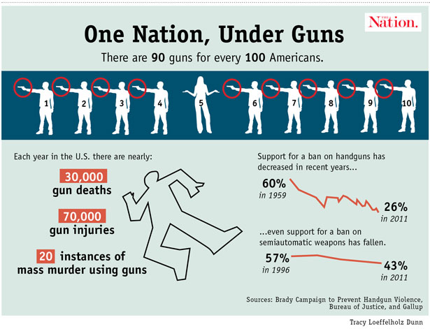

Source 4 – Excerpt from 2015 news article about gun control march

# Moms calling for tighter gun control laws march across Brooklyn Bridge to City Hall

BY [THOMAS TRACY](http://www.nydailynews.com/authors?author=Thomas-Tracy)

NEW YORK DAILY NEWS

Saturday, May 9, 2015, 7:19 PM

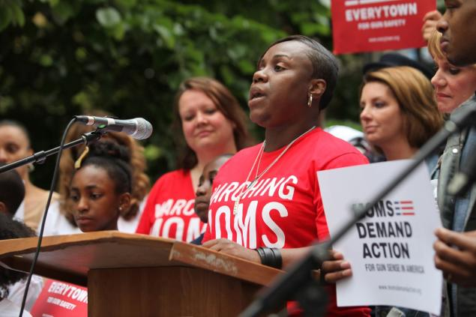

These moms would prefer bullets to bouquets this Mother’s Day—so they can’t be used to kill again.

An army of about 300 angry moms marched across the Brooklyn Bridge and converged on City Hall Saturday to call for tighter gun-control laws and blast America’s apparent lack of “gun sense” one day after fallen [NYPD police officer Brian Moore was laid to rest during a teary funeral.](http://nydn.us/1P6bnm8)

Matriarchs at the Mothers Demand Action for Gun Sense in America march came from as far away as Tennessee, Colorado and Newtown, Conn., where Sandra Scain's daughter was nearly [killed by gunman Adam Lanza in 2012.](http://nydn.us/Ocw2qy)

“My daughter was in the first grade, which was on the other side of the building so she wasn’t hurt physically,” Scain said, holding up a sign reading “Newtown families for gun sense.”

Matriarchs at the Mothers Demand Action for Gun Sense in America march came from as far away as Tennessee, Colorado and Newtown, Conn., where Sandra Scain's daughter was nearly killed by gunman Adam Lanza in 2012.

“Things have to change,” she said of gun laws that allowed Lanza access to an assault weapon. “They must change or there will be more dead children from gun violence every day.”