**Building Blocks for History Lab:**

SS.912.A.5.5 Describe efforts by the United States and other world powers to avoid future wars.

**Essential Question: To what extent did foreign policy during the 1920s and 30s help promote peace in the world?**

Before introducing this history lab to students, they must be familiar with U.S. foreign policy during the post-World War I years, and understand that the United States and much of the rest of the world wanted to prevent another major war. Students must be familiar with the Kellogg-Briand Pact, the U.S. Neutrality Acts, and the League of Nations. Students should also know that the term “appeasement” as used in source 2 refers to the failure of the Allies to do anything to stop Hitler and German expansion of power during the 1930s. Students must also recognize the swastika as a Nazi symbol in order to understand source 2. Finally, students should be familiar with the events leading up to the start of World War II in order to fully understand source 1—particularly that in 1939, when Germany invaded Poland, Britain and France finally declared war.

Related content they should know:

* Kellogg-Briand Pact
* U.S. Neutrality Acts
* League of Nations
* Appeasement

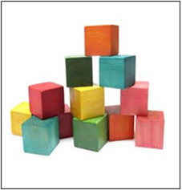

Name _____________________________________________ Period _____ Date _____________________

SS.912.A.5.5 Describe efforts by the United States and other world powers to avoid future wars.

**Essential Question: To what extent did foreign policy during the 1920s and 30s help promote peace in the world?**

|  |  |  |
| --- | --- | --- |
| Source | Main Idea / Message / Important Details | How does this document answer the essential question? |
| Source 1  Political Cartoon about Kellogg-Briand Pact |  |  |
| Source 2  Political Cartoon, “Appeasement Junction” by Dr. Seuss |  |  |
| Source 3  Political cartoon about the League of Nations, 1920 |  |  |
| Source 4  Excerpt from The U.S. Neutrality Act of August 31, 1935 |  |  |

Thesis: _________________________________________________________________________________________________________________________________________________________________________________________________________________________________________________________________________________________________________________________________________________________________________________________________________

Source 1 – Political cartoon about the Kellogg-Briand Pact

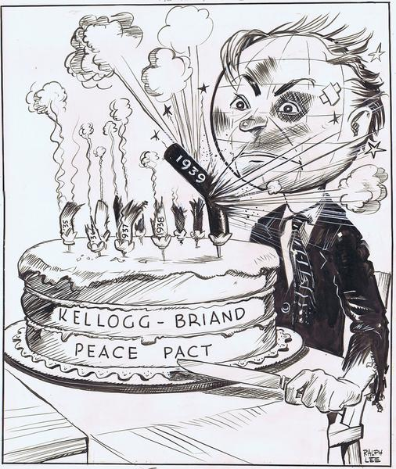

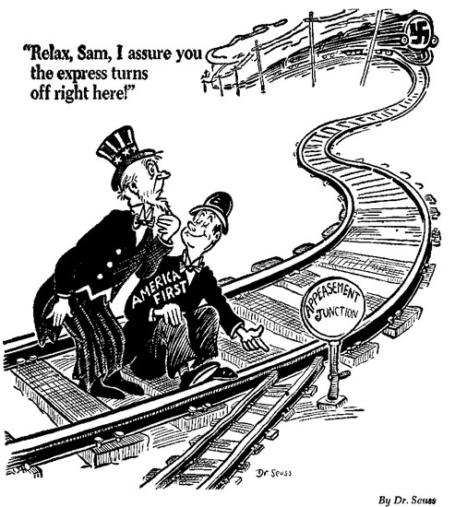Source 2 – Dr. Seuss “Appeasement Junction” Cartoon

Source 3 – Political cartoon about the League of Nations by John T. McCutcheon for the *Chicago Tribune*, 1920

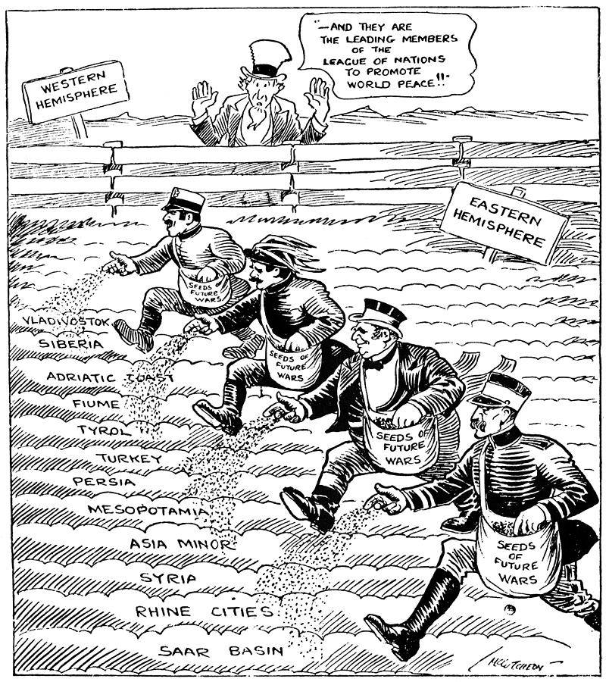

Source 4 – Excerpt from the U.S. Neutrality Act of 1935

“Providing for the prohibition of the export of arms, ammunition, and implements of war to belligerent countries; the prohibition of the transportation of arms, ammunition, and implements of war by vessels of the United States for the use of belligerent states; for the registration and licensing of persons engaged in the business of manufacturing, exporting, or importing arms, ammunition, or implements of war; and restricting travel by American citizens on belligerent ships during war.”