**Building Blocks for History Lab:**

SS.912.A.3.2 Examine the social, political, and economic causes, course, and consequences of the Second Industrial Revolution that began in the late 19th century.

**Essential Question: Were big business leaders “captains of industry” or “robber barons”?**

Before introducing this history lab to students, they must be familiar with how entrepreneurs during the late 19th century contributed to economic growth during the Second Industrial Revolution. Students should be familiar with some of these notable men (Rockefeller, Carnegie, Vanderbilt, etc.), their business practices, and the types of industries they built. Knowing that John Rockefeller built an oil empire would be especially key to students accurately interpreting source 2 in the history lab. Students should also know about Henry Ford’s contribution—the assembly line, which made mass production of automobiles (and other goods) increasingly possible. Additionally, students should know what the Bessemer process is, how it contributed to Andrew Carnegie’s ability to mass produce steel, and the impact that this increased steel production had on economic growth and urbanization. Finally, students should understand the connotations of the terms “captains of industry” and “robber barons” in order to be able to answer the essential question.

Related content they should know:

* “Robber baron” v. “captain of industry”
* Entrepreneurs (Rockefeller, Carnegie, Vanderbilt, Ford, etc.)
* Monopoly
* Assembly line
* Bessemer process

Name _____________________________________________ Period _____ Date _____________________

SS.912.A.3.2 Examine the social, political, and economic causes, course, and consequences of the Second Industrial Revolution that began in the late 19th century.

**Essential Question: Were big business leaders “captains of industry” or “robber barons”?**

|  |  |  |
| --- | --- | --- |
| Source | Main Idea / Message / Important Details | How does this document answer the essential question? |
| Source 1  Political cartoon “The Protectors of Our Industries,” *Puck* Magazine 1883 |  |  |
| Source 2  Political cartoon “What a Funny Little Government,” by Horace Taylor, 1899 |  |  |
| Source 3  Photograph of Ford assembly line |  |  |
| Source 4  Illustration of the Bessemer process |  |  |

Thesis: _________________________________________________________________________________________________________________________________________________________________________________________________________________________________________________________________________________________________________________________________________________________________________________________________________

Source 1 – “The Protectors of Our Industries” 1883

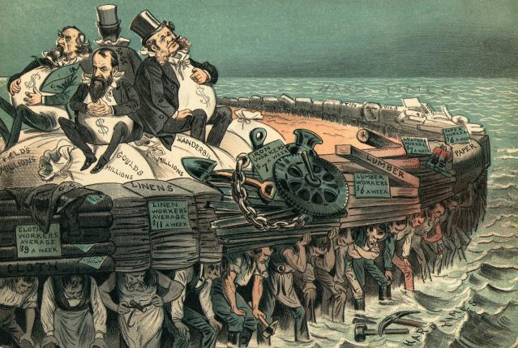

Source 2 – Political Cartoon “What a Funny Little Government”

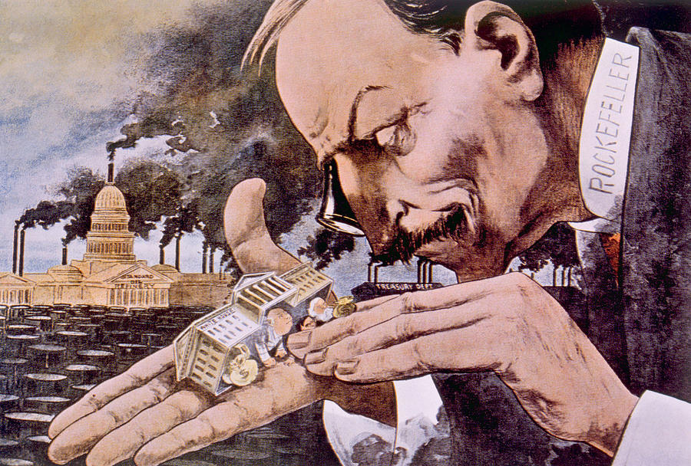

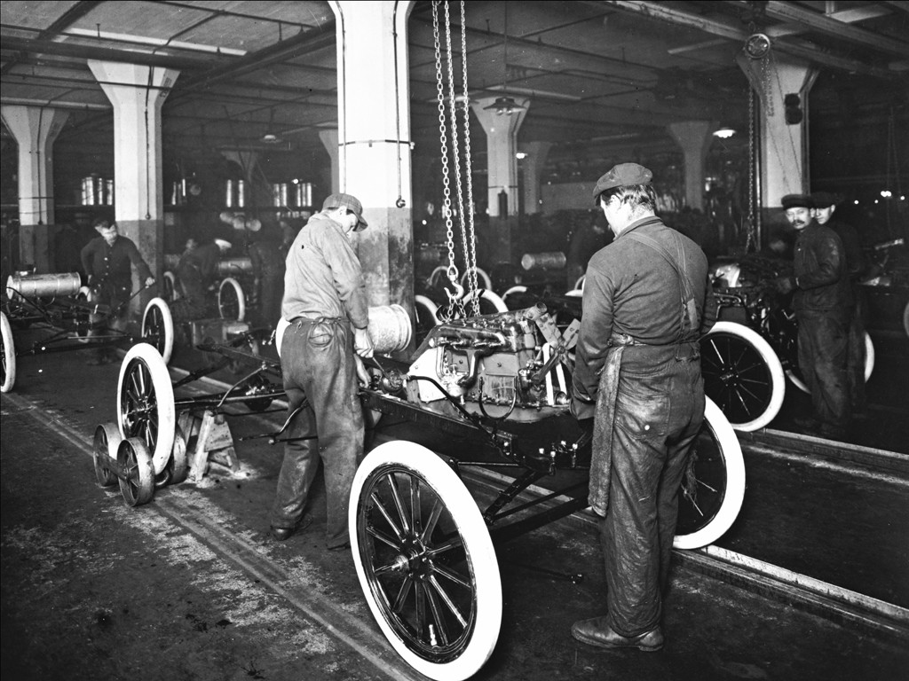Source 3 – Photograph of a Ford factory assembly line

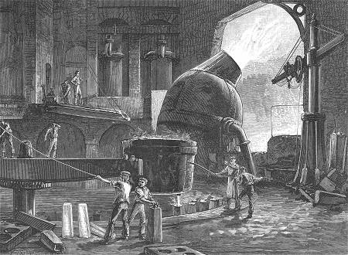Source 4 – Illustration of the Bessemer process