**Building Blocks for History Lab:**

SS.912.A.4.1 Analyze the major factors that drove United States imperialism.

**Essential Question: Was the United States justified in going to war against Spain in 1898?**

Before introducing this history lab to students, they must be familiar with the causes of the Spanish-American War. They should understand that Cuba had been struggling for their freedom from Spain for some time, and that there were many who urged the United States to join and help Cuba to liberate them from Spanish control—Jose Marti is one of these people, for example. Students should also be familiar with the explosion of the U.S.S. Maine and its role in leading to declaration of war against Spain—specifically, they need to know that the destruction of the ship was blamed on Spain at the time, which caused Americans to view them as an enemy. Students must possess the ability to analyze somewhat difficult political cartoons and text excerpts in order to complete this history lab.

Related content they should know:

* Spanish-American War
* Jose Marti
* U.S.S. Maine

Name _____________________________________________ Period _____ Date _____________________

SS.912.A.4.1 Analyze the major factors that drove United States imperialism.

**Essential Question: Was the United States justified in going to war against Spain in 1898?**

|  |  |  |
| --- | --- | --- |
| Source | Main Idea / Message / Important Details | How does this document answer the essential question? |
| Source 1  Jose Marti letter to New York newspaper, 1889 |  |  |
| Source 2  New York Journal front page, Feb. 17, 1898 |  |  |
| Source 3  Political cartoon, “The Spanish Brute,” *Judge* magazine, 1898 |  |  |
| Source 4  Political Cartoon, “The Duplicity of an Old-Time Friend,” June 1898 |  |  |

Thesis: _________________________________________________________________________________________________________________________________________________________________________________________________________________________________________________________________________________________________________________________________________________________________________________________________________

Source 1 – Letter from Jose Marti to the editor of the *New York Evening Post*, March 25, 1889

**Sir: I beg to be allowed the privilege of referring in your columns to the injurious criticism of the Cubans printed in the Manufacturer of Philadelphia, and reproduced in your issue of yesterday.**

**This is not the occasion to discuss the question of the annexation of Cuba. It is probable that no self-respecting Cuban would like to see his country annexed to a nation where the leaders of opinion share towards him the prejudices excusable only to vulgar jingoism or rampant ignorance. No honest Cuban will stoop to be received as a moral pest for the sake of the usefulness of his land in a community where his ability is denied, his morality insulted, and his character despised. There are some Cubans who, from honorable motives, from an ardent admiration for progress and liberty, from a prescience of their own powers under better political conditions, from an unhappy ignorance of the history and tendency of annexation, would like to see the island annexed to the United States. But those who have fought in war and learned in exile, who have built, by the work of hands and mind, a virtuous home in the heart of an unfriendly community; who by their successful efforts as scientists and merchants, as railroad builders and engineers, as teachers, artists, lawyers, journalists, orators, and poets, as men of alert intelligence and uncommon activity, are honored wherever their powers have been called into action and the people are just enough to understand them; those who have raised, with their less prepared elements, a town of workingmen where the United States had previously a few huts in a barren cliff; those, more numerous than the others, do not desire the annexation of Cuba to the United States. They do not need it. They admire this nation, the greatest ever built by liberty, but they dislike the evil conditions that, like worms in the heart, have begun in this mighty republic their work of destruction. They have made of the heroes of this country their own heroes, and look to the success of the American commonwealth as the crowning glory of mankind; but they cannot honestly believe that excessive individualism, reverence for wealth, and the protracted exultation of a terrible victory are preparing the United States to be the typical nation of liberty, where no opinion is to be based in greed, and no triumph or acquisition reached against charity and justice. We love the country of Lincoln as much as we fear the country of Cutting.**

**We are not the people of destitute vagrants or immoral pigmies that the Manufacturer is pleased to picture; nor the country of petty talkers, incapable of action, hostile to hard work, that, in a mass with the other countries of Spanish America, we are by arrogant travelers and writers represented to be. We have suffered impatiently under tyranny; we have fought like men, sometimes like giants, to be freemen; we are passing that period of stormy repose, full of germs of revolt, that naturally follows a period of excessive and unsuccessful action . . .we deserve in our misfortune the respect of those who did not help us in our need.**

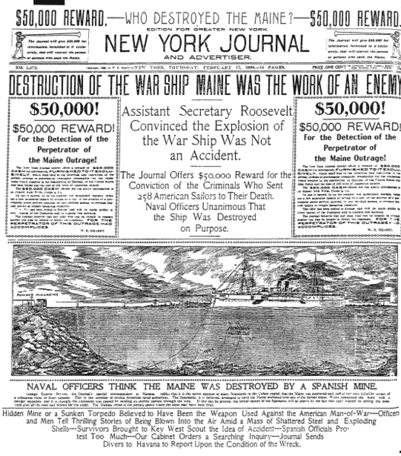Source 2 – *New York Journal* from Feb. 17, 1898

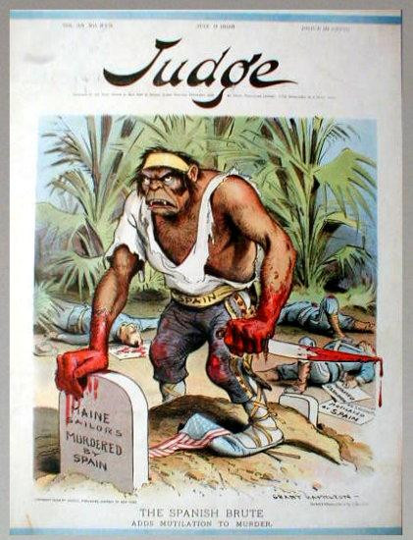Source 3 – Political cartoon “The Spanish Brute”

Source 4 – Political Cartoon “The Duplicity of an Old-Time Friend,” about the French support of Spain in the Spanish-American War.

