**Building Blocks for History Lab:**

SS.912.A.4.1 Analyze the major factors that drove United States imperialism.

**Essential Question: Was the United States justified in going to war against Spain in 1898?**

Before introducing this history lab to students, they must be familiar with the causes and outcome of the Spanish-American War. They should understand that Cuba had been struggling for their freedom from Spain for some time, and that there were many who urged the United States to join and help Cuba to liberate them from Spanish control—Jose Marti is one of these people, for example. Students also must also be familiar with the term “yellow journalism,” which refers to how publishers like Joseph Pulitzer and William Randolph Hearst competed for newspaper sales and profits through their sensationalized headlines and reporting. Students should understand that both Spanish control over Cuba (and Puerto Rico and the Philippines) and yellow journalism were contributing factors that led to the Spanish-American War. Finally, students must also know that one of the Spanish colonial possessions was the Philippines, and that after the war ended, the United States remained in the Philippines fighting Filipinos who wanted their independence for several more years until eventually the U.S. was able to maintain control of the islands and make them a U.S. territorial possession. Many criticized the imperial ambitions of the United States, comparing them to European colonialists and suggesting that it is morally wrong to coerce people into submission, as was done in the Philippine War. Students should have some understanding of the anti-imperialist viewpoint in order to accurately interpret McKinley’s interview in which he defends his decision to annex the Philippines (source 3).

Related content they should know:

* Spanish-American War
* Cuba
* Philippines
* Yellow journalism

Name _____________________________________________ Period _____ Date _____________________

SS.912.A.4.1 Analyze the major factors that drove United States imperialism.

**Essential Question: Was the United States justified in going to war against Spain in 1898?**

|  |  |  |
| --- | --- | --- |
| Source | Main Idea / Message / Important Details | How does this document answer the essential question? |
| Source 1  Political cartoon from *Judge* magazine |  |  |
| Source 2  Political cartoon, “The Big Type War of the Yellow Kids” 1898 |  |  |
| Source 3  Excerpt from President McKinley, 1903 |  |  |
| Source 4  “Free Cuba” cigar advertisement |  |  |

Thesis: _________________________________________________________________________________________________________________________________________________________________________________________________________________________________________________________________________________________________________________________________________________________________________________________________________

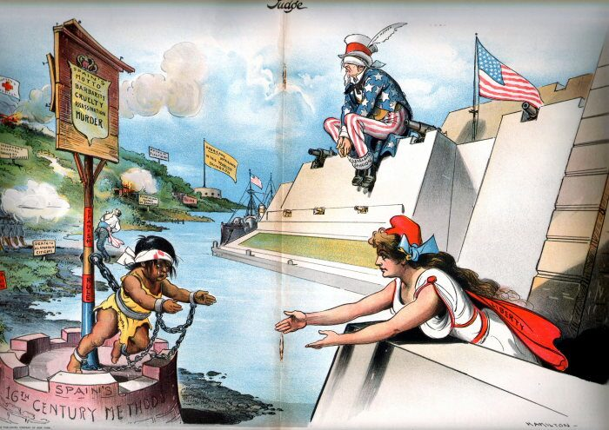Source 1 – *Judge* magazine political cartoon

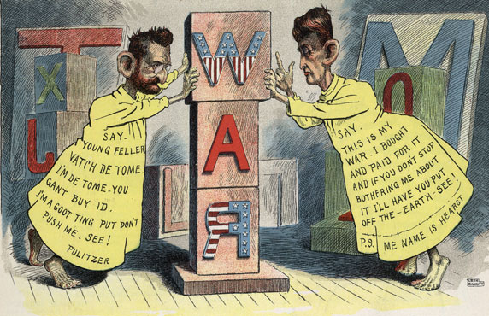Source 2 – Political Cartoon “The Big Type War of the Yellow Kids,” featuring newspaper publishers William Randolph Hearst and Joseph Pulitzer

Source 3 – Excerpt from 1903 interview with President William McKinley about the decision to annex the Philippines

When next I realized that the Philippines had dropped into our laps, I confess I did not know what to do with them. I sought counsel from all sides-Democrats as well as Republicans-but got little help. I thought first we would take only Manila; then Luzon; then other islands, perhaps, also.

I walked the floor of the White House night after night until midnight; and I am not ashamed to tell you, gentlemen, that I went down on my knees and prayed to Almighty God for light and guidance more than one night. And one night late it came to me this way-I don't know how it was, but it came:

(1) That we could not give them back to Spain-that would be cowardly and dishonorable;

(2) That we could not turn them over to France or Germany, our commercial rivals in the Orient-that would be bad business and discreditable;

(3) That we could not leave them to themselves-they were unfit for self-government, and they would soon have anarchy and misrule worse than Spain's was; and

(4) That there was nothing left for us to do but to take them all, and to educate the Filipinos, and uplift and civilize and Christianize them and by God's grace do the very best we could by them, as our fellow men for whom Christ also died.

And then I went to bed and went to sleep, and slept soundly, and the next morning I sent for the chief engineer of the War Department (our map-maker), and I told him to put the Philippines on the map of the United States (pointing to a large map on the wall of his office), and there they are and there they will stay while I am President!

Source 4 – “Free Cuba” advertisement from Schmidt Cigar Co.

