**Building Blocks for History Lab:**

SS.912.A.3.2 Examine the social, political, and economic causes, course, and consequences of the Second Industrial Revolution that began in the late 19th century.

**Essential Question: Did America fulfill the dreams of immigrants in the late 1800s?**

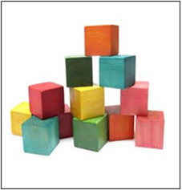Before introducing this history lab to students, they must be familiar with the concept of “new immigrants” versus “old immigrants.” “Old immigrants” refers to those who came in the mid-1800s, mostly from places like Ireland or Germany, and many of whom were Protestant and spoke English. The term “new immigrants” refers to those who came from approximately 1880-1924, mainly from countries in Southern and Eastern Europe. These people were generally Catholic or Jewish, and had different cultural characteristics than those from Northern Europe. Students also need to be familiar with how the U.S. responded to Chinese immigration, passing the Chinese Exclusion Act to prohibit the Chinese from entering the country. Additionally, students should know that the photograph taken by Jacob Riis in source 3 was taken inside a tenement apartment in order to show the conditions that immigrants and industrial workers lived in. Finally, it would be helpful for students to know that the Statue of Liberty is located near Ellis Island, where immigrants entering from Europe were processed when they arrived.

Related content they should know:

* “Old immigrants” v. “new immigrants”
* Chinese Exclusion Act
* Tenement
* Ellis Island

Name _____________________________________________ Period _____ Date _____________________

SS.912.A.3.2 Examine the social, political, and economic causes, course, and consequences of the Second Industrial Revolution that began in the late 19th century.

**Essential Question: Did America fulfill the dreams of immigrants in the late 1800s?**

|  |  |  |
| --- | --- | --- |
| Source | Main Idea / Message / Important Details | How does this document answer the essential question? |
| Source 1  Political Cartoon, “Looking Backward,” *Puck* magazine |  |  |
| Source 2  Political Cartoon, “Be Just—Even to Chinaman,” 1893 |  |  |
| Source 3  Photograph from  *How the Other Half Lives* by Jacob Riis |  |  |
| Source 4  “The New Colossus,” a poem by Emma Lazarus |  |  |

Thesis: _________________________________________________________________________________________________________________________________________________________________________________________________________________________________________________________________________________________________________________________________________________________________________________________________________

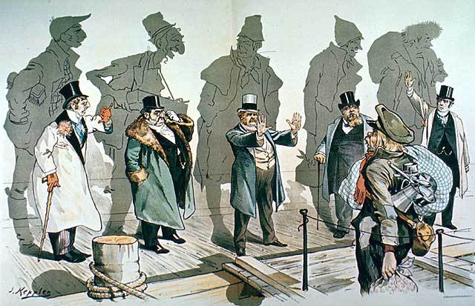Source 1 – Political Cartoon entitled “Looking Backward”

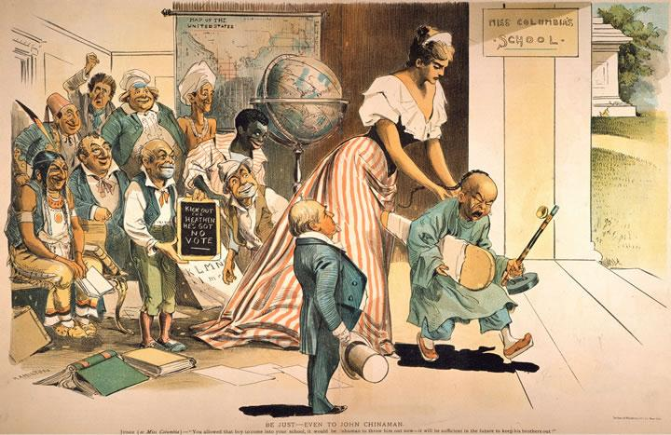Source 2 – Political Cartoon entitled “Be Just—Even to Chinaman”

Source 3 – Photograph by Jacob Riis

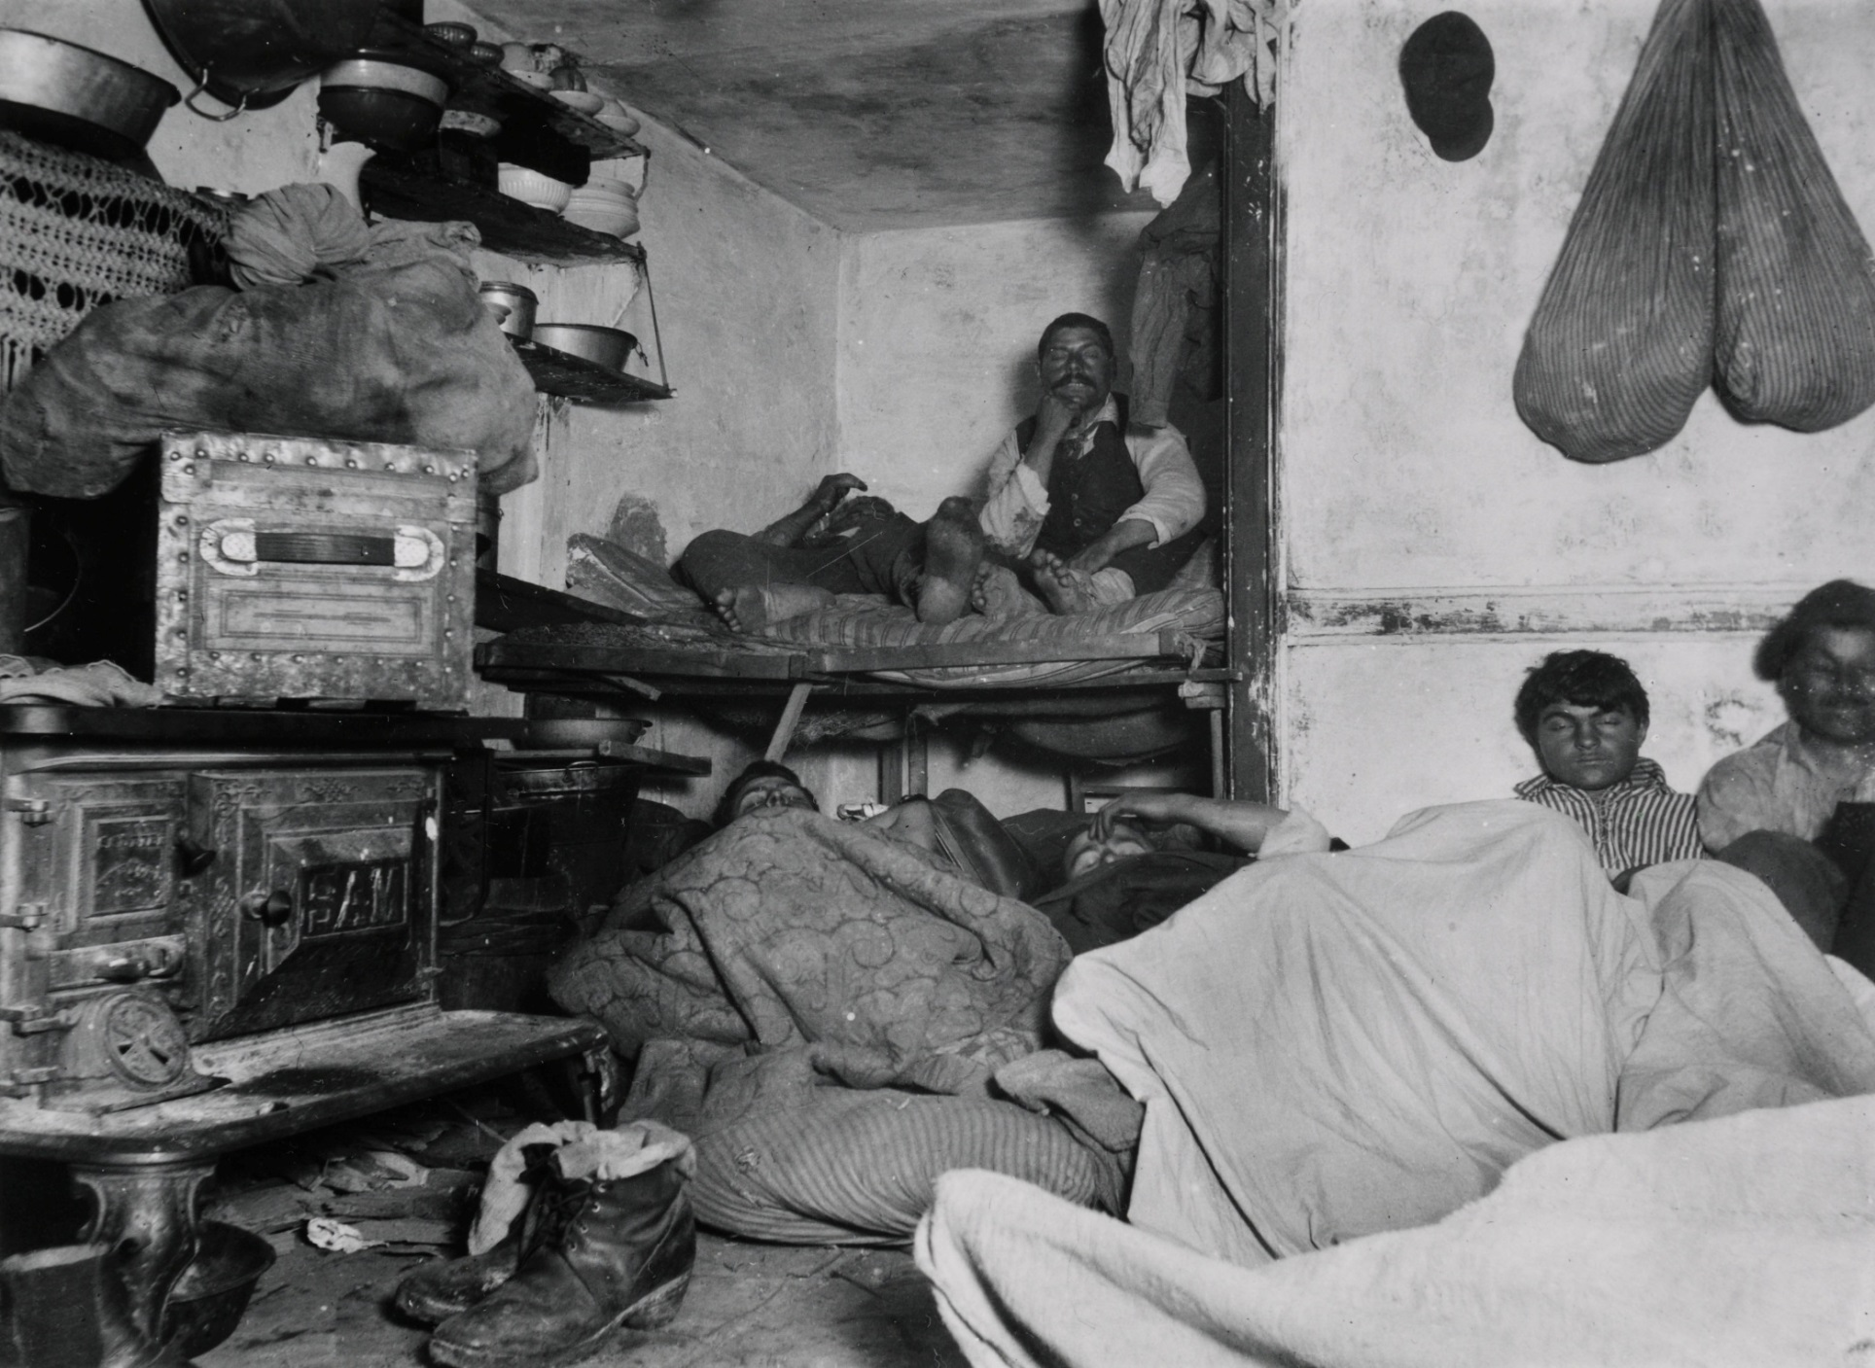

Source 4 – “The New Colossus” by Emma Lazarus, engraved on the Statue of Liberty

***The New Colossus***

***Not like the brazen giant of Greek fame,***

***With conquering limbs astride from land to land;***

***Here at our sea-washed, sunset gates shall stand***

***A mighty woman with a torch, whose flame***

***Is the imprisoned lightning, and her name***

***Mother of Exiles. From her beacon-hand***

***Glows world-wide welcome; her mild eyes command***

***The air-bridged harbor that twin cities frame.***

***"Keep ancient lands, your storied pomp!" cries she***

***With silent lips. "Give me your tired, your poor,***

***Your huddled masses yearning to breathe free,***

***The wretched refuse of your teeming shore.***

***Send these, the homeless, tempest-tost to me,***

***I lift my lamp beside the golden door!"***