**Building Blocks for History Lab:**

SS.912.A.5.11 Examine causes, course, and consequences of the Great Depression and the New Deal.

**Essential Question: Did Franklin Roosevelt’s “New Deal” weaken or save capitalism?**

Before introducing this history lab to students, they must be familiar with Franklin Roosevelt’s New Deal programs—that they were attempts to provide relief from the Great Depression and also reform the U.S. economy in order to prevent another economic crisis of the same magnitude. Students should understand that critics of Roosevelt and the New Deal saw it as an over-extension of executive power and criticized the increased government spending and increased government involvement in the economy under Roosevelt. In order to analyze source 4, students should know the term “planned economy,” should recognize that Stalin was the leader of the Communist Soviet Union, and will probably need to be told that the men in the wagon represent members of FDR’s “brain trust” of advisers and cabinet members, including Tugwell, Wallace, Ickes, and Richberg.

Related content they should know:

* New Deal
* Franklin D. Roosevelt
* Great Depression
* Planned economy

Name _____________________________________________ Period _____ Date _____________________

SS.912.A.5.11 Examine causes, course, and consequences of the Great Depression and the New Deal.

**Essential Question: Did Franklin Roosevelt’s “New Deal” weaken or save capitalism?**

|  |  |  |
| --- | --- | --- |
| Source | Main Idea / Message / Important Details | How does this document answer the essential question? |
| Source 1  “Buy American” poster |  |  |
| Source 2  Political cartoon “More, Please!” 1937 |  |  |
| Source 3  Political cartoon, “What a Man!” by Nelson Harding |  |  |
| Source 4  Political Cartoon, “Planned Economy or Planned Destruction?” |  |  |

Thesis: _________________________________________________________________________________________________________________________________________________________________________________________________________________________________________________________________________________________________________________________________________________________________________________________________________

Source 1 – Poster promoting “Made in America”

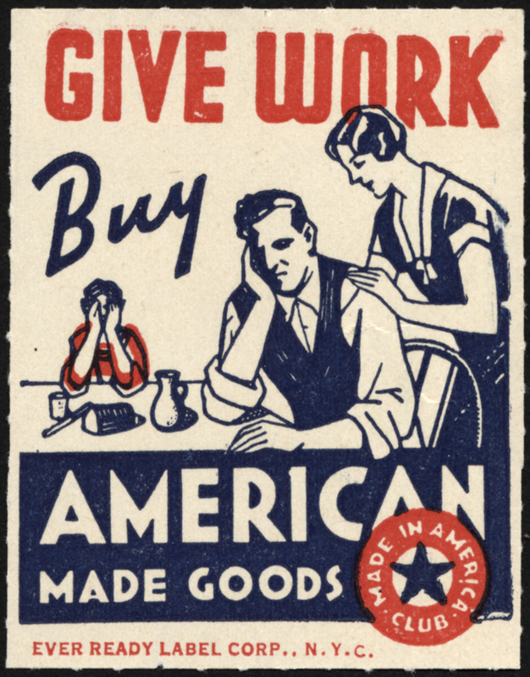

Source 2 – Political cartoon by Joseph L. Parrish in 1937 *Chicago Tribune*

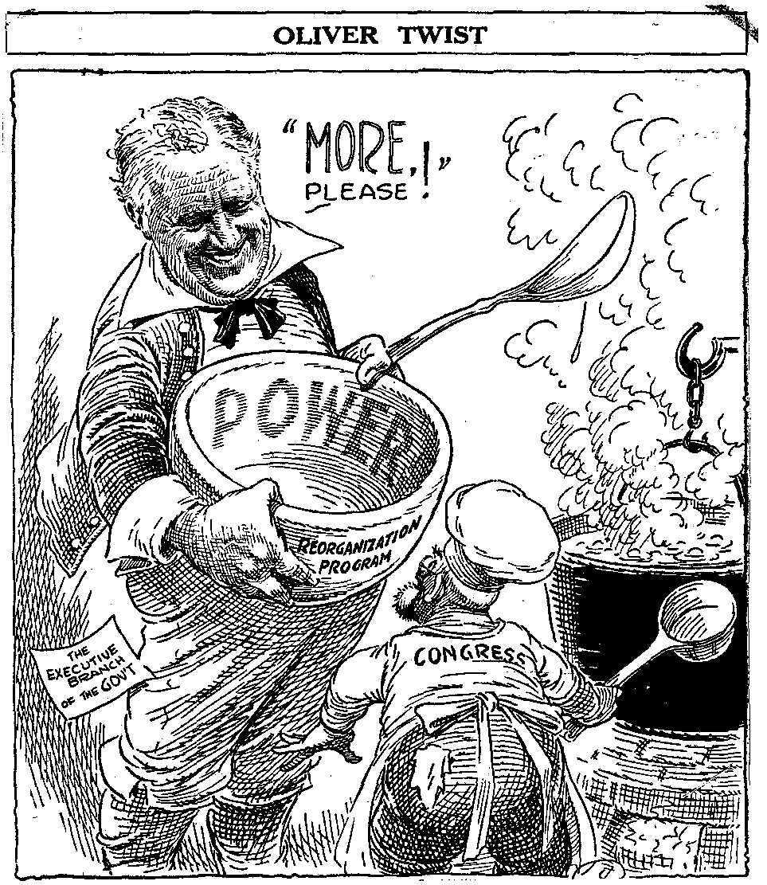

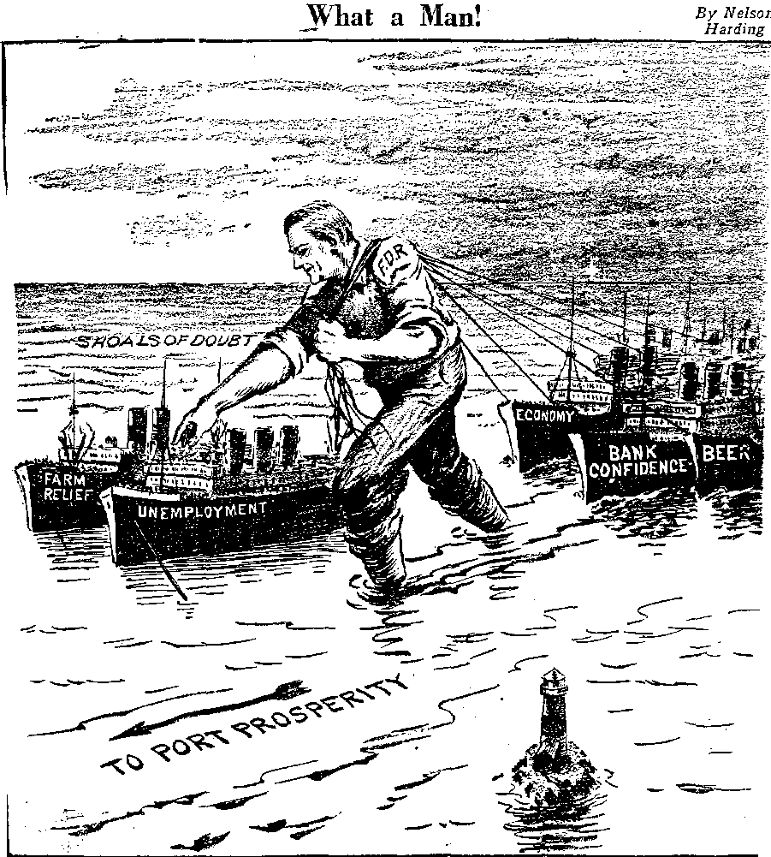

Source 3 – Political cartoon entitled “What a Man!” by Nelson Harding

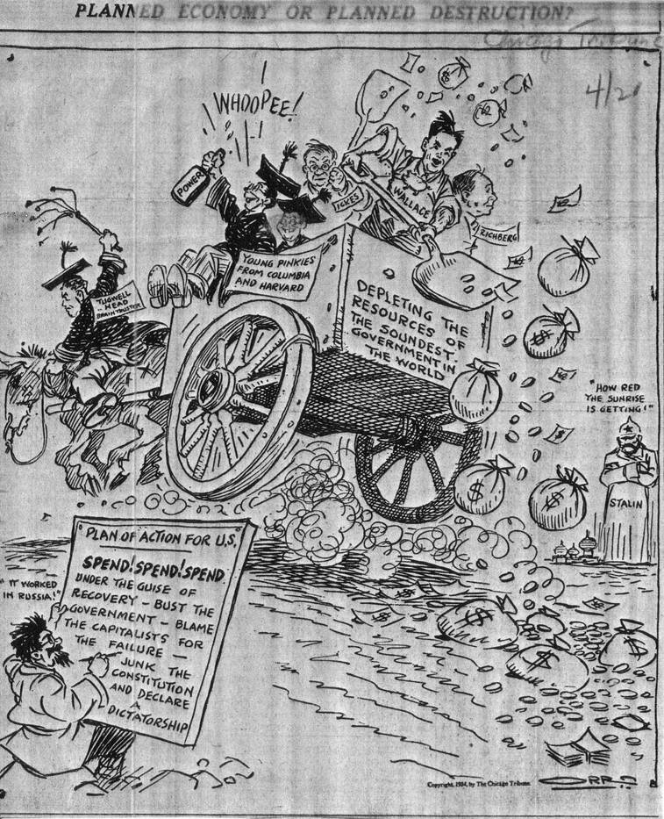

Source 4 – Political Cartoon “Planned Economy or Planned Destruction?”