**Building Blocks for History Lab:**

SS.912.A.3.1 Analyze the economic challenges to American farmers and farmers’ responses to these challenges in the mid to late 1800s.

**Essential Question: Who was to blame for the problems of American farmers after the Civil War?**

Before introducing this history lab to students, they must be familiar with the challenges American farmers faced in the late 1800s, including high shipping prices charged by railroad companies and falling crop prices due to deflation after the Civil War. They should also be familiar with the various ways that farmers responded to these problems, including forming alliances such as the Grange and pushing for reforms such as an end to the gold standard, regulation of railroads by the government, among others. Students should also have a sense of the historical context of the presidential election year of 1896, in which William Jennings Bryan ran as presidential candidate for the Democratic Party and delivered his famous “Cross of Gold” speech. That year the Democratic Party essentially borrowed the Populist Party platform to appeal to farmers and workers alike. Ultimately, the Republican Party’s candidate William McKinley won the election and the gold standard remained. Related content they should know:

* Populist Party
* William Jennings Bryan
* “Cross of Gold” speech
* Bimetallism
* Gold standard
* Sod house
* Grange movement
* Railroad regulation
* Farmers’ Alliances

Name _____________________________________________ Period _____ Date _____________________

SS.912.A.3.1 Analyze the economic challenges to American farmers and farmers’ responses to these challenges in the mid to late 1800s.

**Essential Question: Who was to blame for the problems of American farmers after the Civil War?**

|  |  |  |
| --- | --- | --- |
| Source | Main Idea / Message / Important Details | How does this document answer the essential question? |
| Source 1  Political Cartoon “Swallowed” from *Puck* Magazine |  |  |
| Source 2  Cross of Gold Political Cartoon |  |  |
| Source 3  Photograph of a  sod house |  |  |
| Source 4  Political Cartoon, “The Grange Awakening the Sleepers” 1873 |  |  |

Thesis: _________________________________________________________________________________________________________________________________________________________________________________________________________________________________________________________________________________________________________________________________________________________________________________________________________

Source 1 – Political Cartoon “Swallowed”

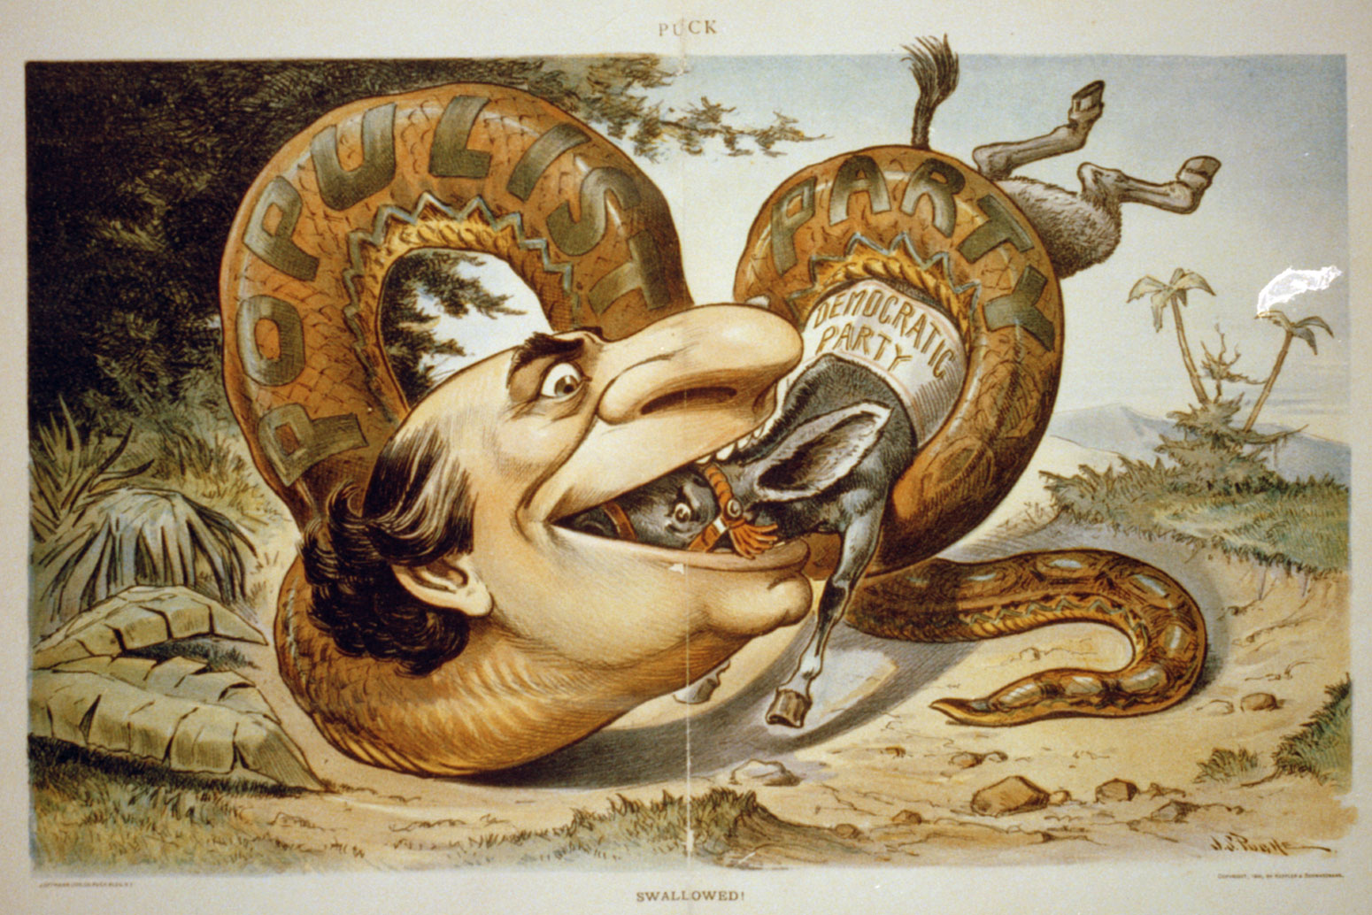

Source 2 – Political Cartoon featuring William Jennings Bryan carrying the “Cross of Gold”

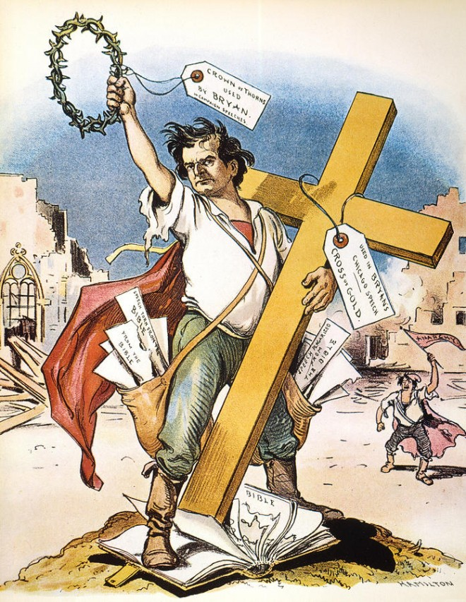

Source 3 – Photograph of a Great Plains “sod house”

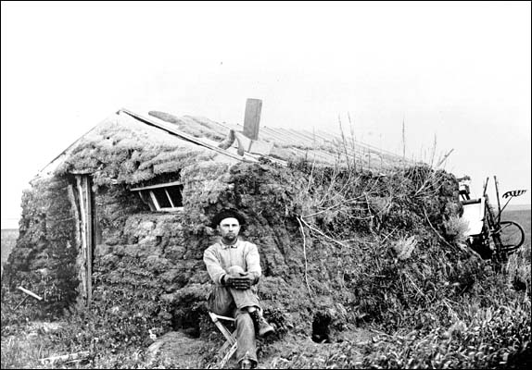

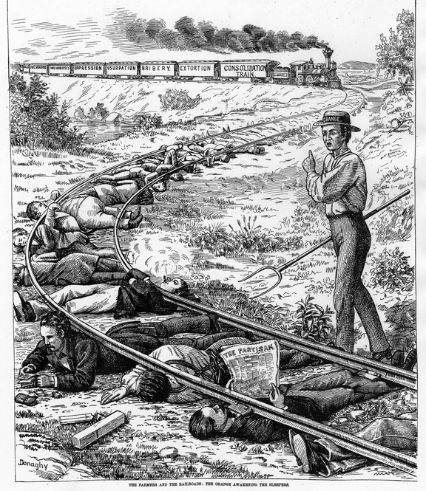Source 4 – Political Cartoon “The Grange Awakening the Sleepers” 1873