**Building Blocks for History Lab:**

SS.912.A.6.10 Examine causes, course, and consequences of the early years of the Cold War (Truman Doctrine, Marshall Plan, NATO, Warsaw Pact)

**Essential Question: To what extent was the containment policy successful?**

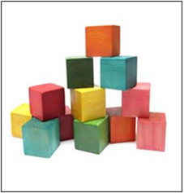Before introducing this history lab to students, they must understand the policy of containment during the early Cold War years. They should know that the containment policy started under President Truman following WWII as an attempt to stop the spread of Communism. In order to successfully analyze source 1 and make a connection to the essential question, students should be familiar with the Berlin airlift, in which necessary supplies were delivered by airplanes to residents of West Berlin after the Soviets blockaded the city. In order to understand source 2, students must also be familiar with the Marshall Plan. Source 3, a Chinese propaganda poster, represents the Chinese point of view towards American policies during this time. Students must be familiar with the Chinese Communist Revolution of 1949 and understand that the Chinese were opponents of U.S. attempts to curb the spread of Communism. Finally, students must be familiar with the outcome of the Korean War, and know the term “38th parallel” referring to the line dividing Communist North Korea and democratic South Korea. Because of the extensive background knowledge required to complete this history lab, it is highly recommended that it be done as a culminating activity after studying the Cold War into the 1950s.

Related content they should know:

* Containment
* Cold War
* Berlin airlift
* Marshall Plan
* Chinese Revolution
* Korean War
* 38th parallel

Name _____________________________________________ Period _____ Date _____________________

SS.912.A.6.10 Examine causes, course, and consequences of the early years of the Cold War (Truman Doctrine, Marshall Plan, NATO, Warsaw Pact)

**Essential Question: To what extent was the containment policy successful?**

|  |  |  |
| --- | --- | --- |
| Source | Main Idea / Message / Important Details | How does this document answer the essential question? |
| Source 1  Poster, “Milk… New Weapon of Democracy!” 1949 |  |  |
| Source 2  Map, Marshall Plan Aid to Europe |  |  |
| Source 3  Chinese propaganda poster created by Xu Ling, 1950 |  |  |
| Source 4  Photograph of 38th parallel, 1950 |  |  |

Thesis: _________________________________________________________________________________________________________________________________________________________________________________________________________________________________________________________________________________________________________________________________________________________________________________________________________

Source 1 – 1949 US government propaganda poster

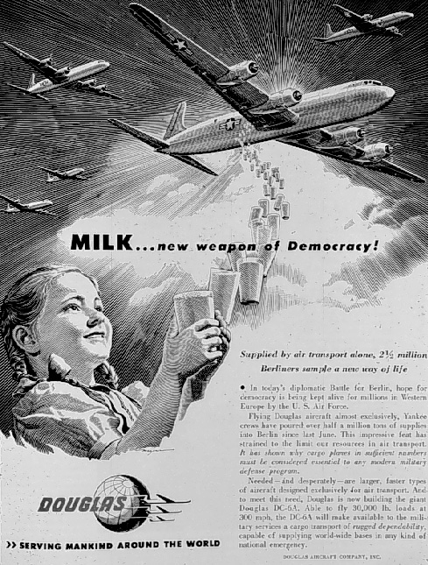

Source 2 – Map illustrating Marshall Plan

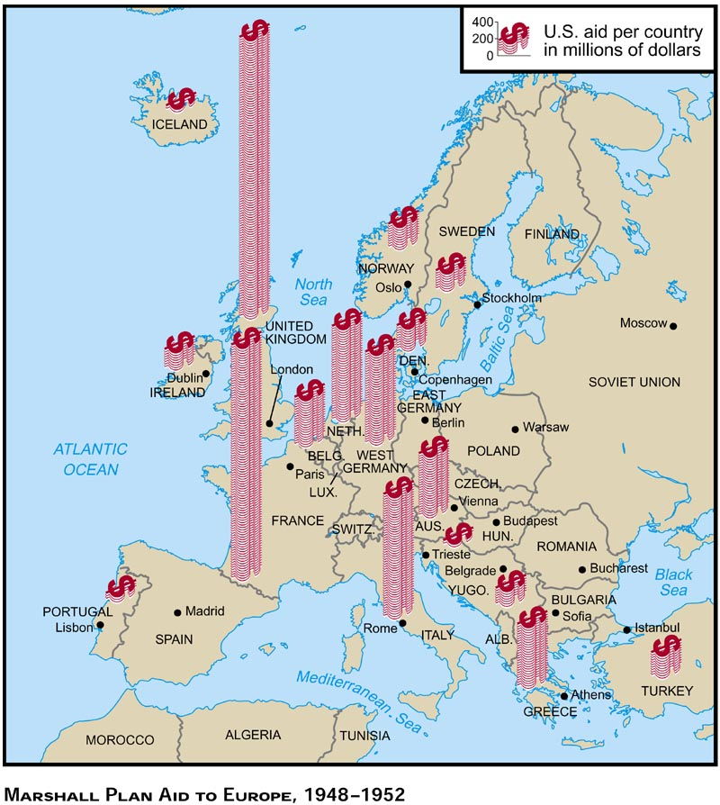

Source 3 – Chinese propaganda poster created by Xu Ling, 1950

[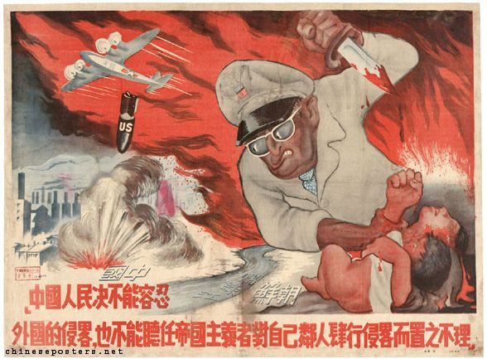](http://chineseposters.net/gallery/e27-169.php)

Source 4 – Photograph of 38th parallel in Korea, 1950

