**Building Blocks for History Lab:**

SS.912.A.2.1 Review causes and consequences of the Civil War.

**Essential Question: Can legislative compromises solve moral issues?**

Before introducing this history lab to students, they must be familiar with the concept of sectionalism and how the conflict over the spread of slavery into new western territories contributed to the tensions that eventually erupted into civil war between the North and South. They should know that Congress attempted to resolve this tension through several compromises – the Missouri Compromise and Compromise of 1850, in particular. They should be familiar with the events that occurred in the years leading up to the Civil War that contributed to the increasing tensions between the pro-slavery South and the North. These events include:

* Compromise of 1850
* Dred Scott decision
* Kansas-Nebraska Act
* Missouri Compromise

Name _____________________________________________ Period _____ Date _____________________

SS.912.A.2.1 Review causes and consequences of the Civil War.

**Essential Question: Can legislative compromises solve moral issues?**

|  |  |  |
| --- | --- | --- |
| Source | Main Idea / Message / Important Details | How does this document answer the essential question? |
| Source 1  Missouri Compromise 1820 Map |  |  |
| Source 2  Kansas-Nebraska Act 1854 Map |  |  |
| Source 3  Majority Opinion in *Dred Scott v. Sanford* excerpt (1857) |  |  |
| Source 4  Political Cartoon, “Southern Chivalry,” 1856 |  |  |

Thesis: ________________________________________________________________________________________________________________________________________________________________________________________________________________________________________________________________________________________________________________________________________________________________________________________________________

Source 1 – Missouri Compromise 1820 Map

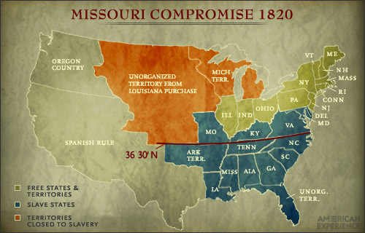

Source 2 Kansas-Nebraska Act 1854 Map

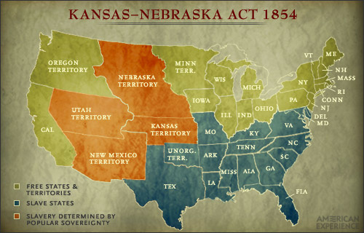

Source 3 – Excerpt from Majority Opinion in Supreme Court case *Dred Scott v. Sanford*

“. . . Can a negro, whose ancestors were imported into this country, and sold as slaves, become a member of the political community formed and brought into existence by the Constitution of the United States, and as such become entitled to all the rights, and privileges, and immunities, guaranteed by that instrument to the citizen? One of which rights is the privilege of suing in a court of the United States in the cases specified in the Constitution.

We think they [people of African ancestry] are not [citizens], and that they are not included, and were not intended to be included, under the word "citizens" in the Constitution, and can therefore claim none of the rights and privileges which that instrument provides for and secures to citizens of the United States.”

Source 4 – Political Cartoon showing Senator Charles Sumner of Massachusetts being attacked by Representative Preston Brooks from South Carolina, 1856

