**Building Blocks for History Lab:**

SS.912.A.7.6 Assess key figures and organizations in shaping the Civil Rights Movement and Black Power Movement.

**Essential Question: Is violence or nonviolence the most effective means to create social change?**

Before introducing this history lab to students, they must know who the Freedom Riders were—the group of students who rode buses along the interstate highways through the South in order to expose segregation along federal roads. The Freedom Riders faced angry mobs in some of the Southern towns they passed through, and in one extreme incident (pictured in source 2) a firebomb was thrown into the bus. Students should also be familiar with the Black Panther Party as radical Black Nationalist organization. Students do not need extensive background knowledge to interpret Sources 1, 3, or 4; these sources contain within themselves what students need in order to connect each source to the essential question.

Related content they should know:

* Freedom Riders
* Black Panthers

Name _____________________________________________ Period _____ Date _____________________

SS.912.A.7.6 Assess key figures and organizations in shaping the Civil Rights Movement and Black Power Movement.

**Essential Question: Is violence or nonviolence the most effective means to create social change?**

|  |  |  |
| --- | --- | --- |
| Source | Main Idea / Message / Important Details | How does this document answer the essential question? |
| Source 1  Excerpt from Dr. Martin Luther King, Jr. speech, 1963. |  |  |
| Source 2  Photograph of Freedom Riders |  |  |
| Source 3  Photograph of dog attacking protestor in Birmingham, Ala., 1963 |  |  |
| Source 4  Newsletter from San Diego Black Panther Party |  |  |

Thesis: _________________________________________________________________________________________________________________________________________________________________________________________________________________________________________________________________________________________________________________________________________________________________________________________________________

Source 1 – Excerpt from Dr. Martin Luther King’s 1963 speech “Strength to Love”

**Darkness cannot drive out darkness;  
only light can do that.  
Hate cannot drive out hate;  
only love can do that.  
Hate multiplies hate,  
violence multiplies violence,  
and toughness multiplies toughness  
in a descending spiral of destruction....  
The chain reaction of evil --  
hate begetting hate,  
wars producing more wars --  
must be broken,  
or we shall be plunged  
into the dark abyss of annihilation.  
  
Dr. Martin Luther King, Jr.**Strength To Love, 1963

Source 2 – Photographic image of Freedom Riders’ burning bus

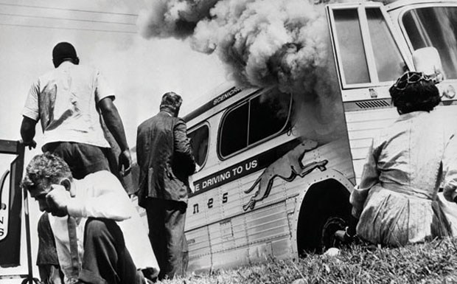

Source 3 – Photograph of police dog attacking protestor in Birmingham, Alabama, 1963

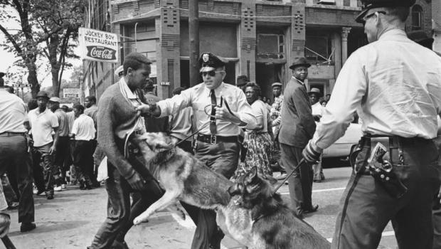

Source 4 – Black Panther San Diego branch newsletter, 1969

