AP Psychology

Select one book from the list below to read this summer. The selections are from a wide variety of psychology-related topics and there should be something of interest for everyone. If you have an idea for a book that you think may fit the format, please see Ms. Castillo ahead of time to get approval.

First, Type up a one and a half page (12-font; double-spaced) summary of the book.
Next, add another one and a half to two pages of reflection and analysis.

Include:
How does this book explain/examine human behavior?
What did you learn that can relate to your own life?
What questions were raised that you hope to have answered this year in this class?

Popular Psychology Books

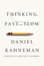Thinking, Fast and Slow (Hardcover)
by Daniel Kahneman
Want to Read

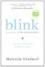Blink: The Power of Thinking Without Thinking (Paperback)
by Malcolm GladwellWant to Read

Man's Search for Meaning (Paperback)
by Viktor E. Frankl

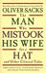The Man Who Mistook His Wife for a Hat and Other Clinical Tales (Paperback)
by Oliver Sacks
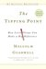The Tipping Point: How Little Things Can Make a Big Difference (Paperback)
by Malcolm Gladwell
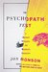The Psychopath Test: A Journey Through the Madness Industry (Paperback)
by Jon Ronson
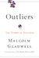Outliers: The Story of Success (Hardcover)
by Malcolm Gladwell

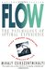Flow: The Psychology of Optimal Experience (Paperback)
by Mihaly Csikszentmihalyi
The Interpretation of Dreams (Hardcover)
by Sigmund Freud
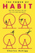The Power of Habit: Why We Do What We Do in Life and Business (Hardcover)
by Charles Duhigg
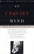An Unquiet Mind: A Memoir of Moods and Madness (Paperback)
by Kay Redfield Jamison
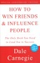How to Win Friends and Influence People (Paperback)
by Dale Carnegie
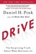Drive: The Surprising Truth About What Motivates Us (Hardcover)
by Daniel H. Pink (Goodreads Author)
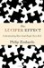The Lucifer Effect: Understanding How Good People Turn Evil (Hardcover)
by Philip G. Zimbardo
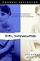Girl, Interrupted (Paperback)
by Susanna Kaysen
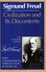Civilization and Its Discontents (Paperback)
by Sigmund Freud
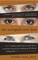The Sociopath Next Door (Paperback)
by Martha Stout
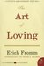The Art of Loving (Paperback)
by Erich Fromm
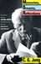Memories, Dreams, Reflections (Paperback)
by C.G. Jung

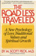The Road Less Traveled: A New Psychology of Love, Traditional Values, and Spiritual Growth (Paperback)
by M. Scott Peck
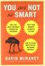You Are Not So Smart: Why You Have Too Many Friends on Facebook, Why Your Memory Is Mostly Fiction, and 46 Other Ways You're Deluding Yourself (Hardcover)
by David McRaney
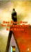One Flew Over the Cuckoo's Nest (Mass Market Paperback)
by Ken Kesey

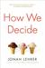How We Decide (Hardcover)
by Jonah Lehrer
Love's Executioner and Other Tales of Psychotherapy (Paperback)
by Irvin D. Yalom
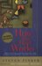How the Mind Works (Paperback)
by Steven Pinker
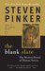The Blank Slate: The Modern Denial of Human Nature (Paperback)
by Steven Pinker
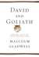David and Goliath: Underdogs, Misfits, and the Art of Battling Giants (Hardcover)
by Malcolm Gladwell
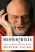Musicophilia: Tales of Music and the Brain (Hardcover)
by Oliver Sacks
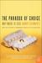The Paradox of Choice: Why More Is Less (Paperback)
by Barry Schwartz
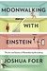Moonwalking with Einstein: The Art and Science of Remembering Everything (Hardcover)
by Joshua Foer
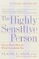The Highly Sensitive Person: How to Thrive When the World Overwhelms You (Paperback)
by Elaine N. Aron
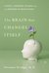The Brain That Changes Itself: Stories of Personal Triumph from the Frontiers of Brain Science (Hardcover)
by Norman Doidge
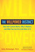The Willpower Instinct: How Self-Control Works, Why It Matters, and What You Can Do to Get More of It (Hardcover)
by Kelly McGonigal
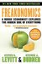Freakonomics: A Rogue Economist Explores the Hidden Side of Everything (Freakonomics, #1)
by Steven D. Levitt
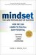Mindset: The New Psychology of Success (Hardcover)
by Carol S. Dweck

Rate this book
1 of 5 stars2 of 5 stars3 of 5 stars4 of 5 stars5 of 5 stars
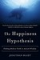The Happiness Hypothesis: Finding Modern Truth in Ancient Wisdom (Paperback)
by Jonathan Haidt
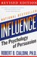Influence: The Psychology of Persuasion (Paperback)
by Robert B. Cialdini
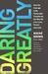Daring Greatly: How the Courage to Be Vulnerable Transforms the Way We Live, Love, Parent, and Lead (Hardcover)
by Brené Brown
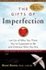The Gifts of Imperfection: Let Go of Who You Think You're Supposed to Be and Embrace Who You Are (Paperback)
by Brené Brown
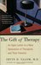The Gift of Therapy: An Open Letter to a New Generation of Therapists and Their Patients (Paperback)
by Irvin D. Yalom
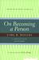On Becoming a Person: A Therapist's View of Psychotherapy (Paperback)
by Carl R. Rogers
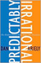Predictably Irrational: The Hidden Forces That Shape Our Decisions (Hardcover)
by Dan Ariely
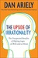The Upside of Irrationality: The Unexpected Benefits of Defying Logic at Work and at Home (Hardcover)
by Dan Ariely

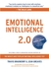Emotional Intelligence 2.0 (Hardcover)
by Travis Bradberry
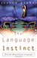The Language Instinct: How the Mind Creates Language (Paperback)
by Steven Pinker
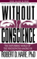Without Conscience: The Disturbing World of the Psychopaths Among Us (Paperback)
by Robert D. Hare
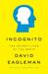Incognito: The Secret Lives of the Brain (Hardcover)
by David Eagleman

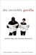The Invisible Gorilla: And Other Ways Our Intuitions Deceive Us (Hardcover)
by Christopher Chabris
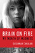Brain on Fire: My Month of Madness (Hardcover)
by Susannah Cahalan
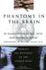Phantoms in the Brain: Probing the Mysteries of the Human Mind (Paperback)
by V.S. Ramachandran

