**Building Blocks for History Lab:**

SS.912.A.7.1 Identify causes for post-World War II prosperity and its effects on American society.

**Essential Question: To what extent were the 1950s a time of great peace, progress, and prosperity for Americans?**

Before introducing this history lab to students, they must know what the GI Bill was, and how it led to new opportunities for World War II veterans returning from the war. Additionally, students should have some familiarity with the growth of the suburbs, the baby boom, and the automobile industry after World War II. Students should be able to critically consider the role of women during the post-war years—particularly middle class women who lived in the suburbs. Students need to be proficient in visual analysis, graph analysis, and reading comprehension to accurately analyze each source. It is highly recommended that this history lab be completed before beginning study of SS.912.A.7.6, as it sets up the opportunity to discuss inequality in America during the post-WWII years that contributed to the emerging Civil Rights Movement.

Related content they should know:

* GI Bill
* Suburbs
* Baby boom

Name _____________________________________________ Period _____ Date _____________________

SS.912.A.7.1 Identify causes for post-World War II prosperity and its effects on American society.

**Essential Question: To what extent were the 1950s a time of great peace, progress, and prosperity for Americans?**

|  |  |  |
| --- | --- | --- |
| Source | Main Idea / Message / Important Details | How does this document answer the essential question? |
| Source 1  GI Bill Poster |  |  |
| Source 2  1956 Ford Car Commercial, (search [www.youtube.com](http://www.youtube.com) for “1956 Ford Customline Victoria Ranch Wagon Car Commercial” |  |  |
| Source 3  U.S. Census graph, Percentage of Managers Who Are Women: 1940-2009 |  |  |
| Source 4  Excerpt from *The Other America* by Michael Harrington |  |  |

Thesis: _________________________________________________________________________________________________________________________________________________________________________________________________________________________________________________________________________________________________________________________________________________________________________________________________________

****Source 1 – GI Bill Poster

Source 3 – United States Census Bureau Graph

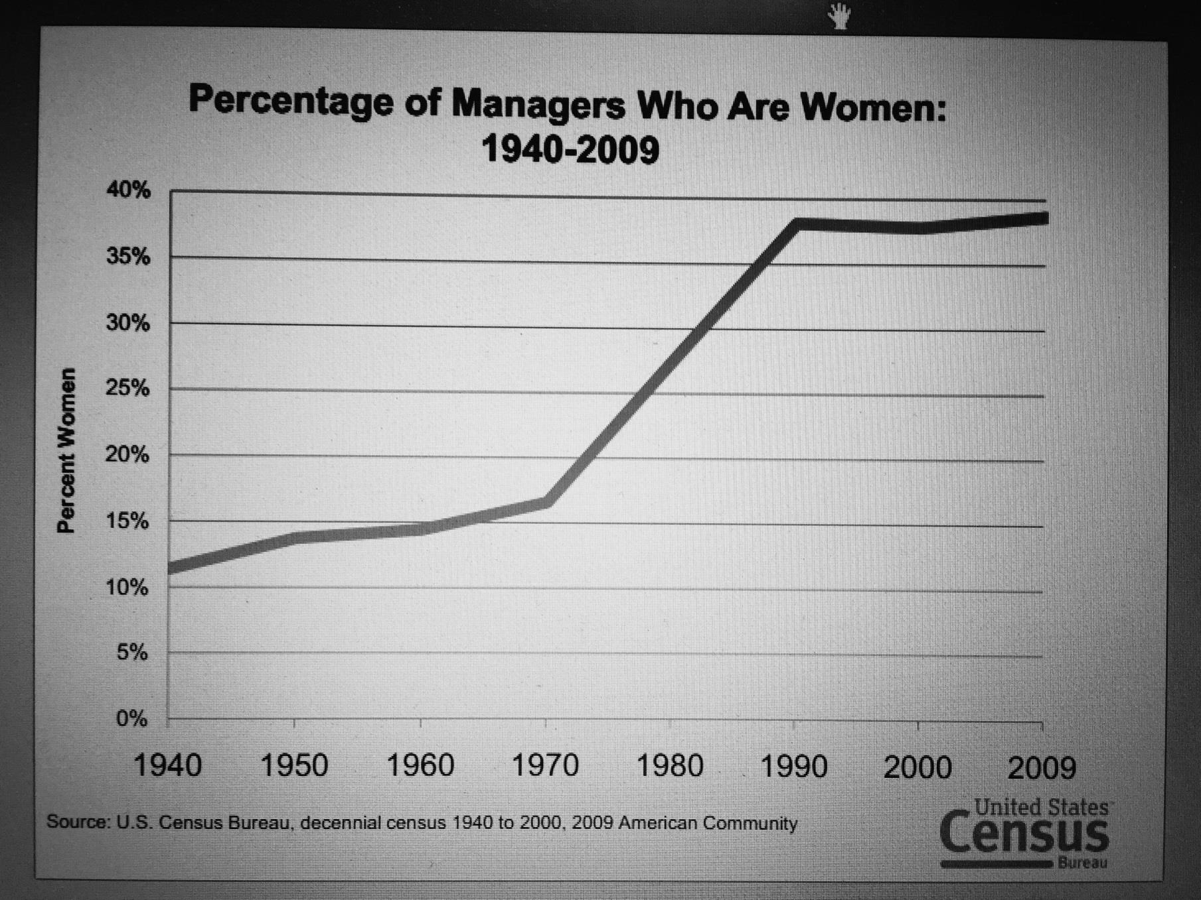

Source 4 – Excerpt from *The Other America* by Michael Harrington, 1962

There is a familiar America. It is celebrated in speeches and advertised on television and in the magazines. It has the highest mass standard of living the world has ever known….

…In this theory the nation’s problems were no longer a matter of basic human needs, of food, shelter, and clothing. Now they were seen as qualitative, a question of learning to live decently amid luxury.

While this discussion was carried on, there existed another America. In it dwelt somewhere between 40,000,000 and 50,000,000 citizens of this land. They were poor. They still are.

To be sure, the other America is not impoverished in the same sense as those poor nations where millions cling to hunger as a defense against starvation. This country has escaped such extremes. That does not change the fact that tens of millions of Americans are, at this very moment, maimed in body and spirit, existing at levels beneath those necessary for human decency. If these people are not starving, they are hungry, and sometimes fat with hunger, for that is what cheap foods do. They are without adequate housing and education and medical care.

The millions who are poor in the United States tend to become increasingly invisible. Here is a great mass of people, yet it takes an effort of the intellect and will even to see them.

There are perennial reasons that make the other America an invisible land.

Poverty is off the beaten track. It always has been. The ordinary tourist never left the main highway, and today he rides interstate turnpikes. He does not go into the valleys of Pennsylvania where the towns look like movie sets of Wales in the thirties. He does not see the company houses in rows, the rutted roads (the poor always have bad roads, whether they live in the city, in towns, or on farms), and everything is black and dirty. And even if he were to pass through such a place by accident, the tourist would not meet the unemployed men in the bar or the women coming home from a runaway sweatshop.

…Now the American city has been transformed. The poor still inhabit the miserable housing in the central area, but they are increasingly isolated from contact with, or sight of, anybody else. Middle-class women coming in from Suburbia on a rare trip may catch the merest glimpse of other America on the way to an evening at the theater, but the children are segregated in suburban schools. The business or professional man may drive along the fringes of slums in a car or bus, but it is not an important experience to him. The failure, the unskilled, the disabled, the aged, and the minorities are right there, across the tracks, where they have always been. But hardly anyone else is.

In short, the very development of the American city has removed poverty from the living, emotional experience of millions upon millions of middle-class Americans. Living out in the suburbs, it is easy to assume that ours is, indeed, an affluent society…