**Building Blocks for History Lab:**

SS.912.A.5.10 Analyze support for and resistance to civil rights for women, African Americans, Native Americans, and other minorities.

**Essential Question: Why did African Americans leave the South in the early 20th century? Were they seeking better jobs or social freedom?**

Before introducing this history lab to students, they must know about the Great Migration, when millions of African Americans moved from the South to Northern cities during the years of the early 20th century. There is no specific required background knowledge needed in order for students to analyze the sources, other than to recognize that Chicago is a city located in the North to which many African Americans moved during the Great Migration.

Related content they should know:

* Great Migration

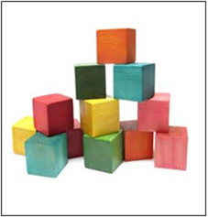

Name _____________________________________________ Period _____ Date _____________________

SS.912.A.5.10 Analyze support for and resistance to civil rights for women, African Americans, Native Americans, and other minorities.

**Essential Question: Why did African Americans leave the South in the early 20th century? Were they seeking better jobs or social freedom?**

|  |  |  |
| --- | --- | --- |
| Source | Main Idea / Message / Important Details | How does this document answer the essential question? |
| Source 1  Political Cartoon, “To the North”, *The Crisis* (1920) |  |  |
| Source 2  Jacob Lawrence Painting, “The Migration of the Negro”, 1940 |  |  |
| Source 3  Image of a Black Family Arriving in Chicago, 1919 |  |  |
| Source 4  Image from Chicago Race Riots June 1919 |  |  |

Thesis: _________________________________________________________________________________________________________________________________________________________________________________________________________________________________________________________________________________________________________________________________________________________________________________________________________

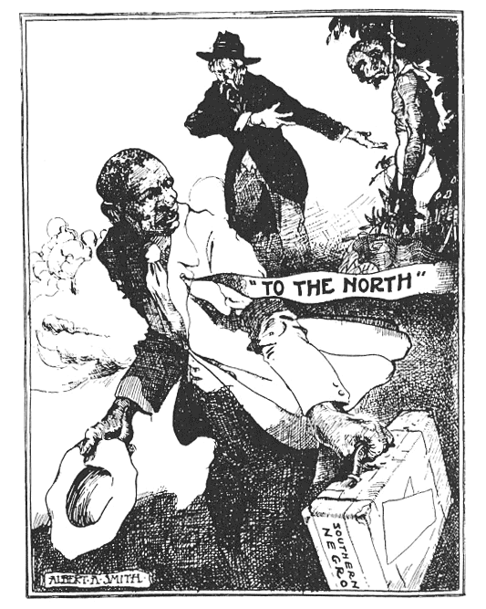Source 1 – “To the North” Political Cartoon

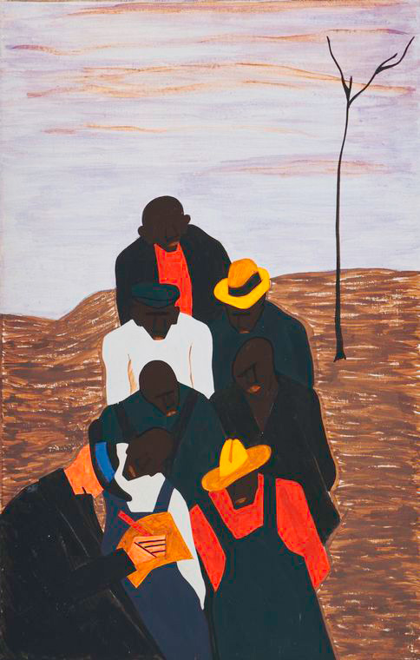Source 2 – Jacob Lawrence painting

Source 3 – Photographic image of black family arriving in Chicago from the South

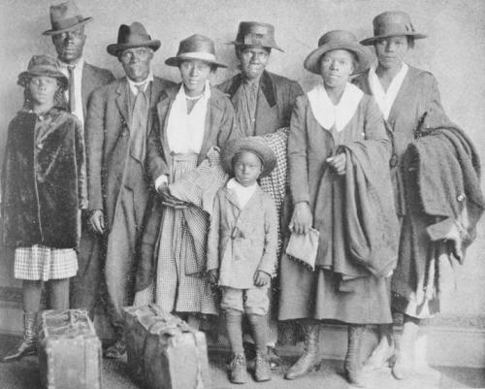

Source 4 – Photographic image showing after-effects of Chicago race riots of 1919.

