**Building Blocks for History Lab:**

SS.912.A.5.3 Examine the impact of United States foreign economic policy during the 1920s.

**Essential Question: Was American foreign policy in the 1920s “internationalist” or “isolationist”?**

Before introducing this history lab to students, they must be familiar with U.S. foreign policy during the post-World War I years. Students should know that the League of Nations was an international organization formed to prevent future wars, but that the United States never joined, despite being an idea proposed by our own president (Woodrow Wilson). Students should also recognize the Dawes Plan as an attempt to provide financial assistance to stabilize the European economy after World War I. Additionally, students need to know that the Kellogg-Briand Pact was an international agreement to avoid using war to resolve disputes. Finally, students should know about the immigration quota laws passed in the United States during the 1920s to greatly limit European immigration. Before allowing students to work on the history lab, make sure that they understand the difference between the terms “internationalist” and “isolationist” so they understand what the essential question is asking.

Related content they should know:

* League of Nations
* Dawes Plan
* Kellogg-Briand Pact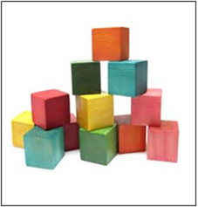
* Immigration quota laws

Name _____________________________________________ Period _____ Date _____________________

SS.912.A.5.3 Examine the impact of United States foreign economic policy during the 1920s.

SS.912.A.5.5 Describe efforts by the United States and other world powers to avoid future wars.

**Essential Question: Was American foreign policy in the 1920s “internationalist” or “isolationist”?**

|  |  |  |
| --- | --- | --- |
| Source | Main Idea / Message / Important Details | How does this document answer the essential question? |
| Source 1  Political cartoon, “The Gap in the Bridge” |  |  |
| Source 2  Diagram illustrating the Dawes Plan |  |  |
| Source 3  Newspaper headline announcing Kellogg-Briand Pact |  |  |
| Source 4  Political cartoon, “The Only Way to Handle It,” 1921 |  |  |

Thesis: _________________________________________________________________________________________________________________________________________________________________________________________________________________________________________________________________________________________________________________________________________________________________________________________________________

Source 1 – Political Cartoon “The Gap in the Bridge”

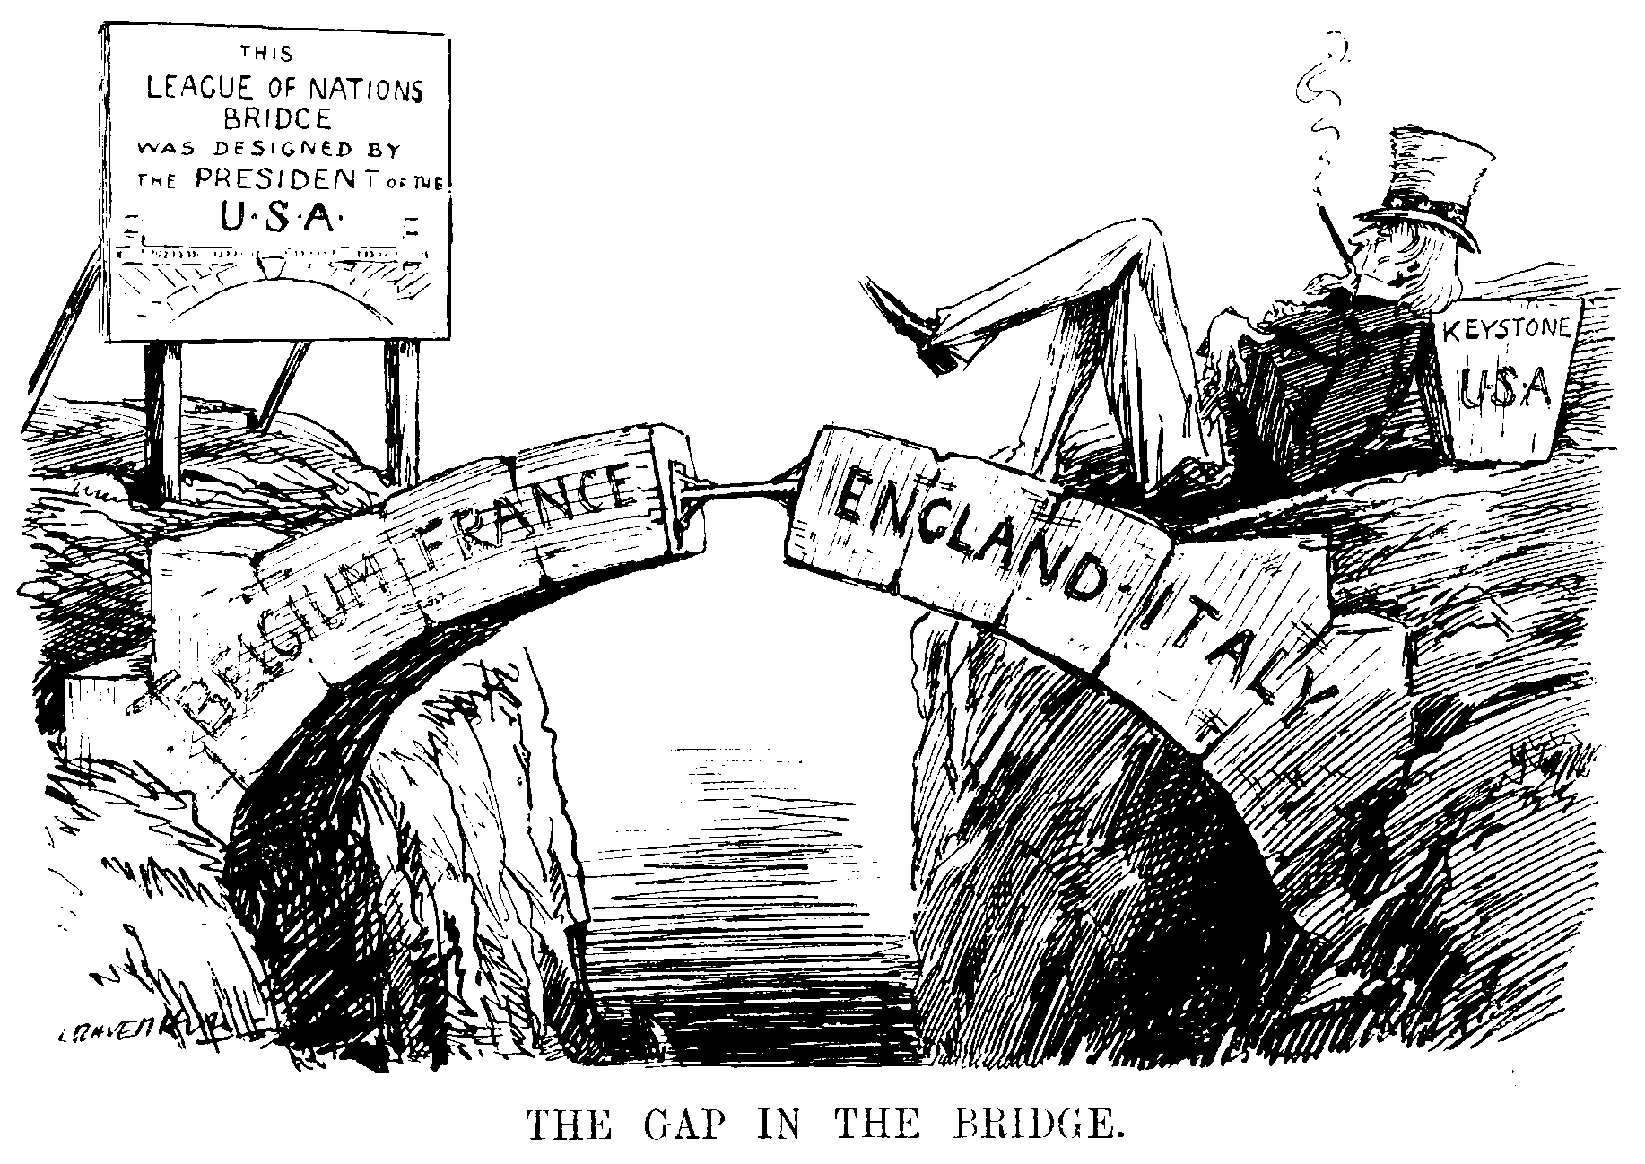

Source 2 – Diagram illustrating the Dawes Plan

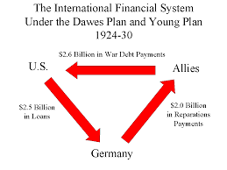

Source 3 – Newspaper headline announcing Kellogg-Briand Pact

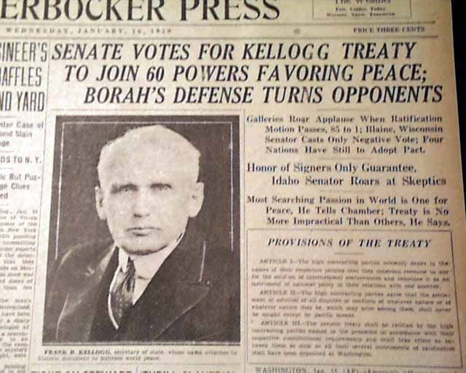

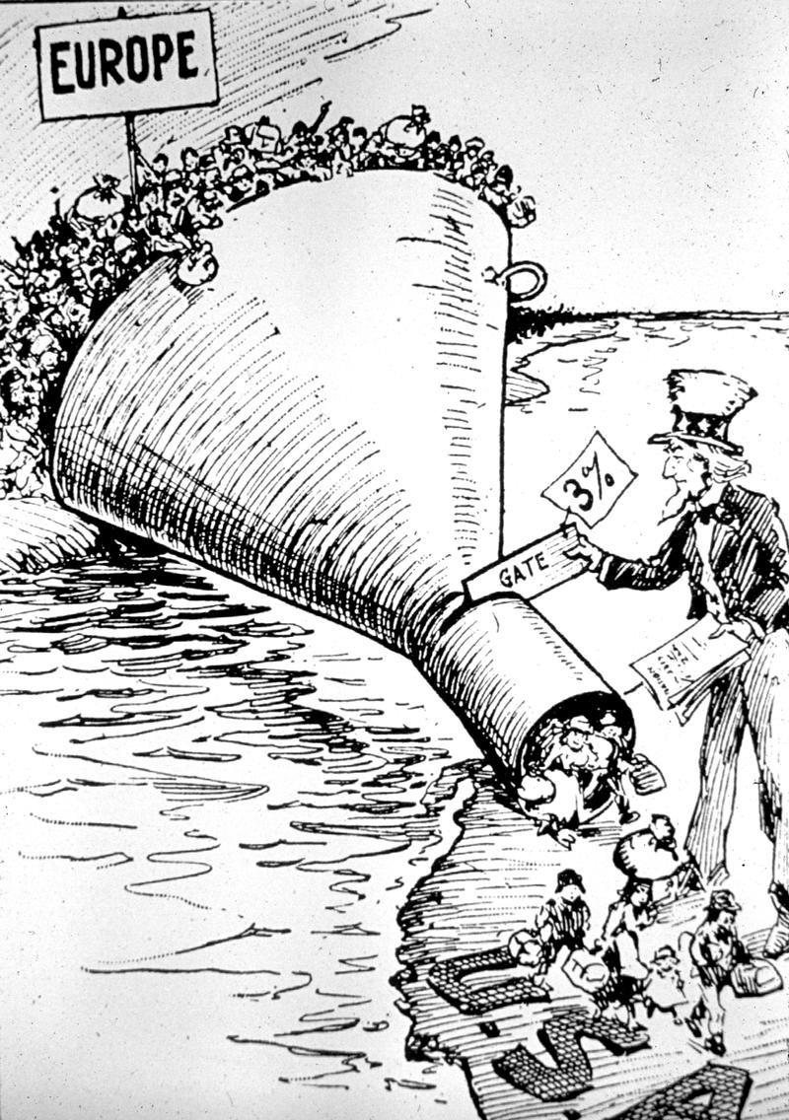Source 4 – Political cartoon, “The Only Way to Handle It,” 1921